🎭 Rehearsal Recap
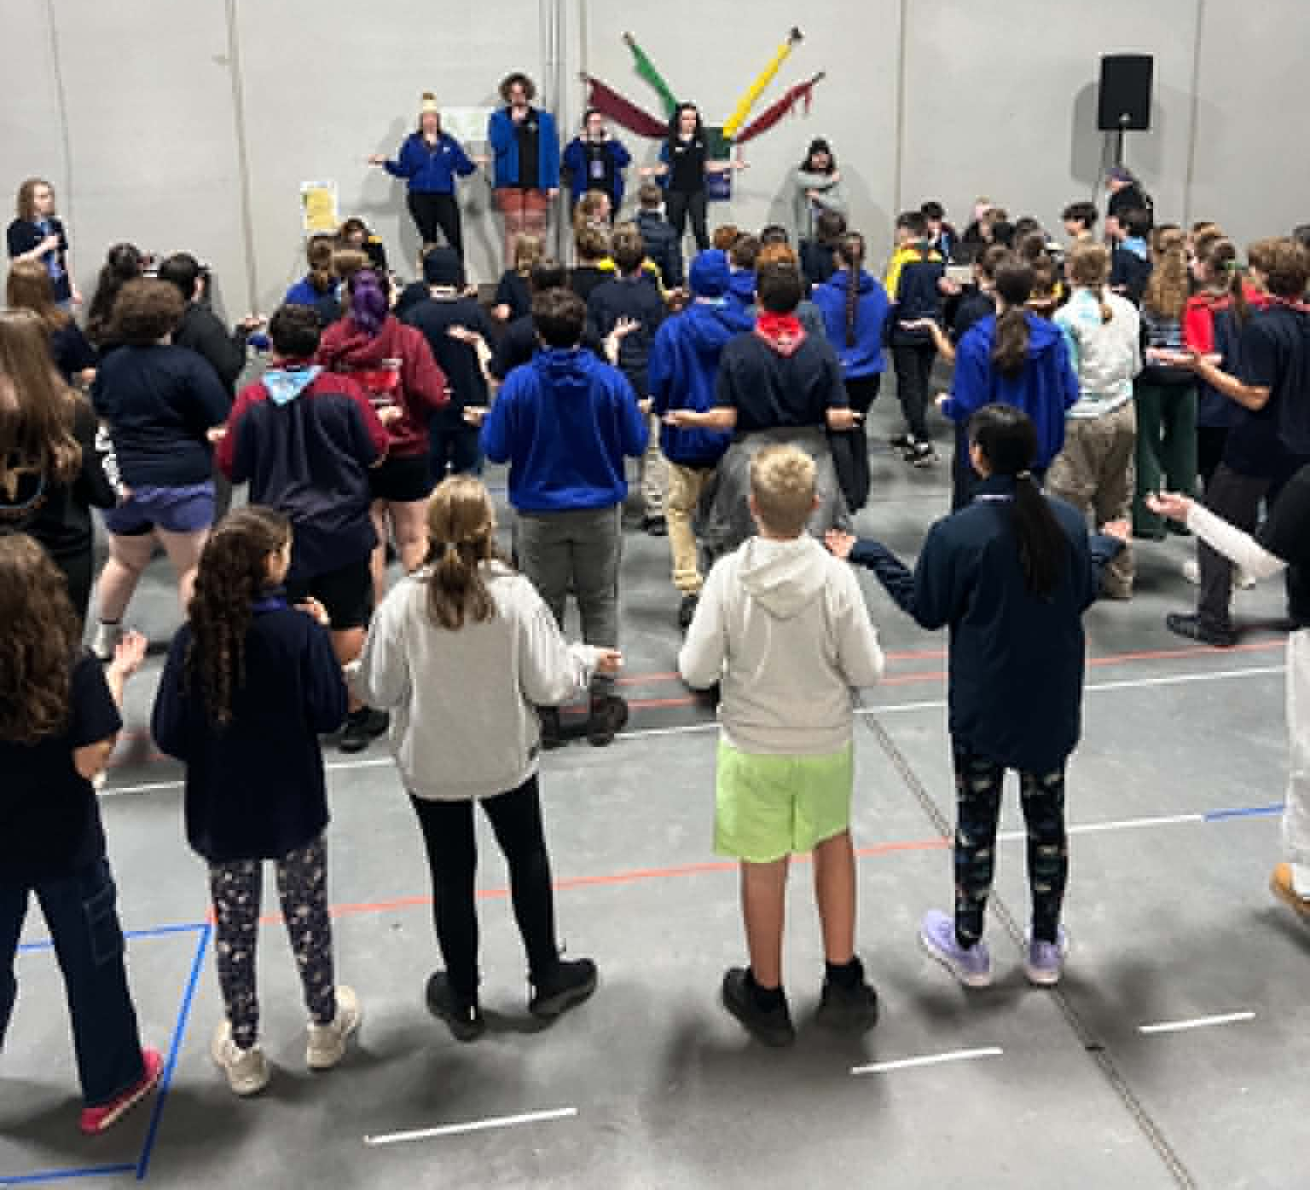
Good rehearsal tonight everyone. After going through items from act 1 such as the opening, Jen and buried, turn the pages, and dancing to survive there have definitely been a number of items identified tonight that need some work either in terms of refining or more practice rehearsing in our own time so please work on those.
Also recommend working on learning the lyrics at home too and if you want to push yourself, sing the words while rehearsing the dance as this will help you when it comes time for theatre. Only 11 weeks until theatre and 2 of those are school holidays so make sure you get that practice in. Well done to those who came to the early rehearsal, keep up the good work. Hope to see you all refreshed and ready to rehearse again in a couple of weeks.
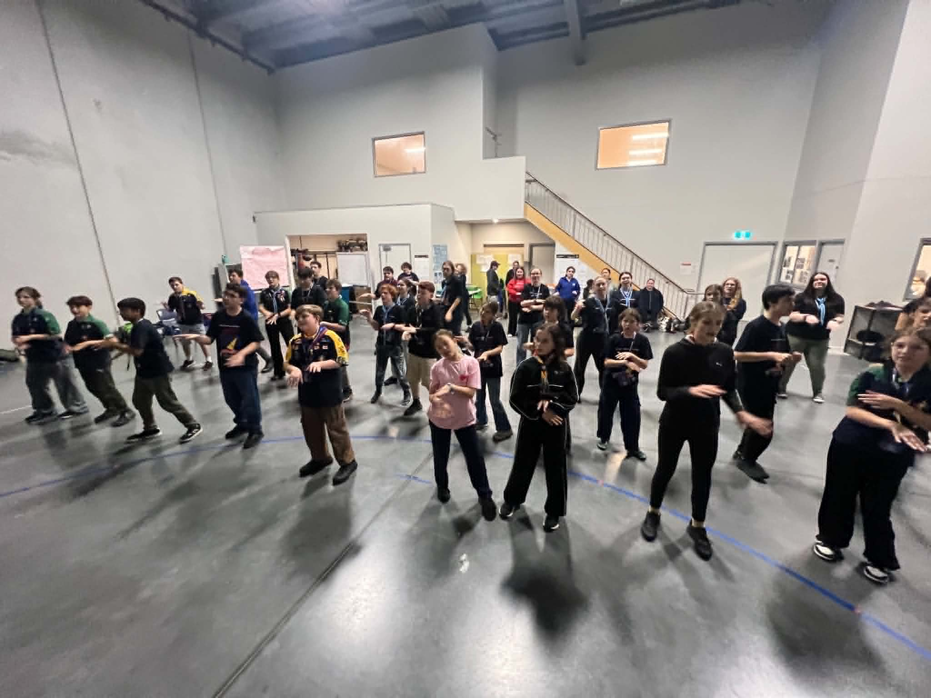
— Kieren
Next Rehearsal
No rehearsal next week (Sunday 7th June) due to King's Birthday Weekend. We’ll see you on Sunday 14th June
🗓️ Date: Sunday 14th June
🕔 Time: 5:45pm to 8:30pm
📍 Venue: 1st Carrum Downs (Rehearsal Venue)
💼 Please bring your Script, Pen, Water Bottle and Lanyard with name tag.
Running late? Unwell? Can’t make it? Please text Stabby on 0432 285 154
Duty Patrols:
Astor (Opening) - Phoenix (Closing)
Members in these patrols will need to arrive 10 mins earlier to set up and stay back to pack up (approx 10 mins)
Special Rehearsal - Book baddies (5:00pm)
The following Cast members are required for a special rehearsal at 5:00pm:
Lea Z | Connor S | Elyssia G | Teagan P | Lucy R | Dinal W | Jonah C
Elliot M

Special Rehearsal - Along the grapevine (5:00pm)
The following Cast members are required for a special rehearsal at 5:00pm:
Lizzie H | Kieren M | Maxwell R | Lauren H | Grace W | Alice G | Patrick D
Lillian D | Indie B | Jackson L

If you’re unable to make it to a Special Rehearsal - Please let Stabby know on 0432285154

📍 Where to Find Important Stuff — The Members Area!
Head to southmetroshowtime.org, and in the top right-hand corner of the website you’ll see a button labelled “Members”. Click on this and enter this year’s password to access the full Members Area.

Password: 2026SMST!

Birthday Shoutouts!
A huge shout out and Happy Birthday to the following SMST Members who are celebrating their birthday this week:
Tahlia White-Cann (Palais)
Wishing all our SMST members a birthday filled with laughter, fun and lots of cake!

South Metro Showtime BBQ Fundraiser

One of the ways we keep South Metro Showtime affordable for our families is through fundraising, and we're looking for volunteers to help at our upcoming Bunnings BBQ!


📅 Sunday 28th June
📍 Bunnings Carrum Downs

By volunteering for a shift, you'll be helping:

🎭 Support the running costs of South Metro Showtime

💰 Keep cast fees as low as possible

🤝 Support the wider South Metro Showtime community

We are seeking volunteers for the following shifts:

☀️ Morning Shift – 8:00am to 11:30am (5 volunteers required)

🍔 Lunch Shift – 11:30am to 2:00pm (6 volunteers required)

🌭 Afternoon Shift – 2:00pm to 4:30pm (5 volunteers required)

Parents, carers, family members, and supporters are all welcome to help. Even a few hours of your time makes a huge difference to the success of the fundraiser.

👉 To volunteer, please sign up using the Google Sheet via the link or QR Code provided.
https://docs.google.com/spreadsheets/d/1bqE18z70YcYbSlRskP9Qv2p8vBXaXEg5HGfXC3kSRX8/edit?usp=sharing

Thank you for helping South Metro Showtime continue to provide an amazing experience for our cast, crew, and families!

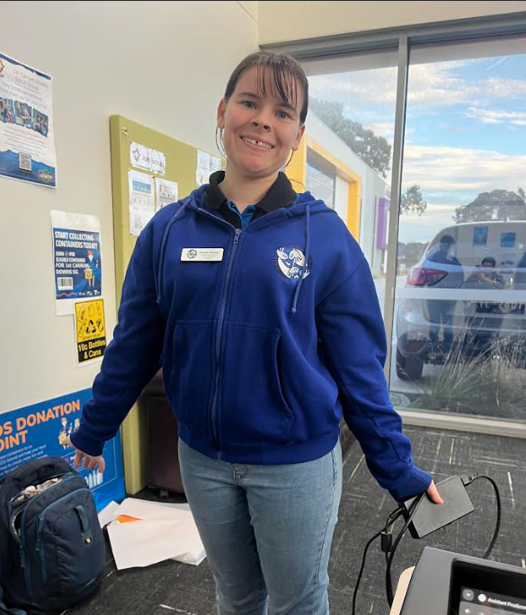
🧥 SMST Merch Store! Now Open
Want to rep Showtime in style and stay warm this winter? Our royal blue SMST zip-up hoodies are now available to pre-order through our online webstore! And now we’ve got Beanies too!
These are an optional extra and perfect for rehearsals, school, or just showing your Showtime pride out and about.
For Hoodies, once we receive 20 orders, the batch will be processed — so encourage your castmates to get on board too! Beanies are in stock right now!
🛒 Order now at:
https://shop.fullypromoted.com.au/south-metro-showtime
Please note the following,
- The first time you use the link, DON’T TRY TO CREATE A USER OR LOGIN
- Place the order for the items.
- When you go to check out fill out all the details
- At the end it will ask you to enter the password
- This will automatically create you a login
You can use this login to check what you have ordered in the past and make further orders after your first order 💙 Look sharp, stay cosy, and show off that Showtime spirit!
Social Media!
Adults (being over 18) in Scouting must not befriend Youth Members on social media, nor respond to requests to befriend (except family). This also applies in reverse, youth members (under 18) are not to follow or request to follow adults on Social Media.
Adults in Scouting should not interact privately with Youth Members in any form of social media. Where social media is used to organise events (Scouting activity) a publicly ‘open group’ or event/activity network involving more than one Adult and more than one Youth Member is to be used. This provision does not mean that an Adult cannot also be a friend of a Youth Member, nor does it mean that an Adult cannot provide mentoring and support to individual Youth Members in their Scouting roles, however, in Child Protection terms, Adults in Scouting carry a higher duty of care, not only for Youth Members, but also to the Scout Association. This responsibility overrides the need for private relationships online. Please email Breanne at marketing@southmetroshowtime.org if you need any clarification.
💰 Fees Reminder – Thank You & Final Call!
A big thank you to all cast members and families who have already paid their show fees or arranged a payment plan — we really appreciate it!
If you haven’t yet paid or organised a plan, fees are now overdue. These payments help us cover important behind-the-scenes costs and all the magic that brings Showtime to life.
If you're having trouble or need support setting up a payment plan, please get in touch with the team at finance@southmetroshowtime.org as soon as possible. We're here to help — but we do need to hear from you!
Let’s keep the show rolling smoothly — thank you for your cooperation and support! 🎭

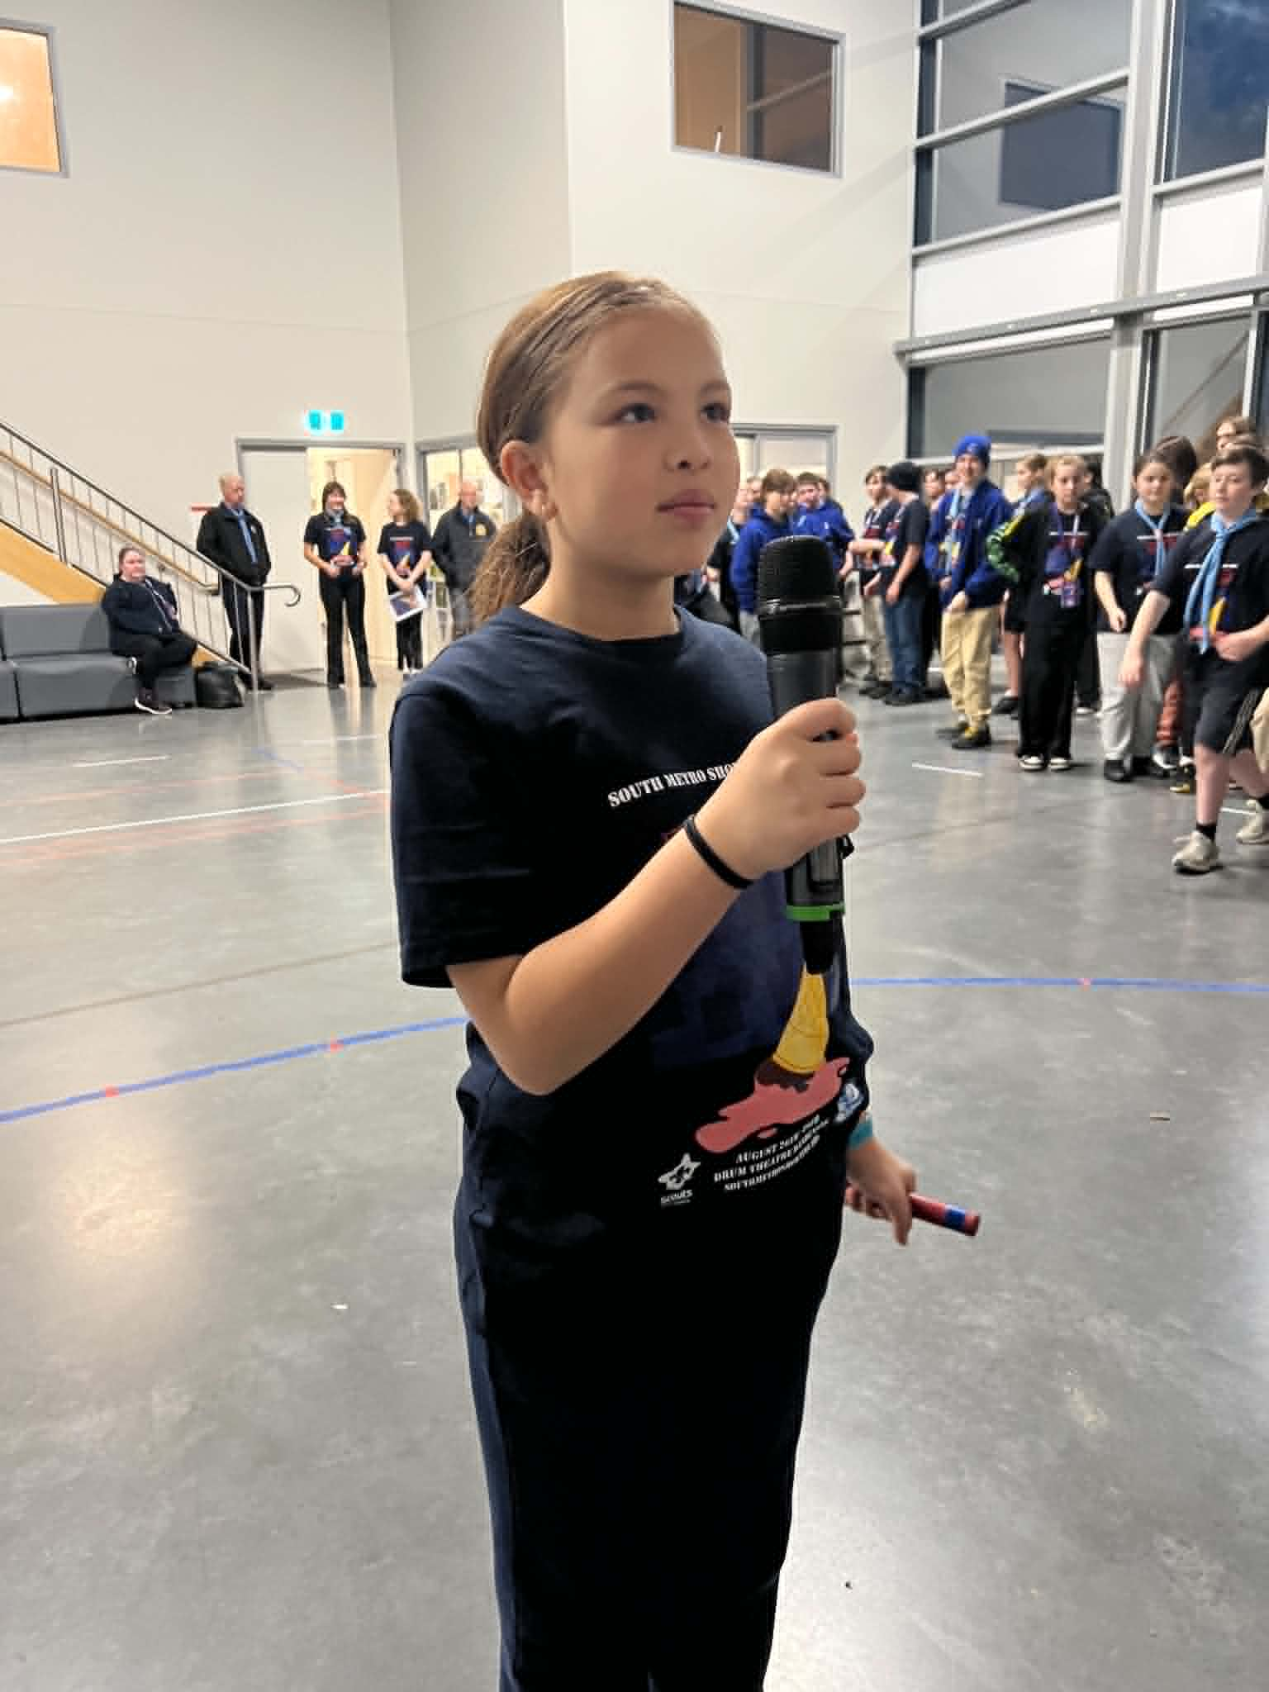
🍰 What Dessert Am I? - Quiz Question 🤔

I’m golden on the outside and soft in the middle,
I’m often served warm with custard or ice cream,
You might find fruit hiding inside me...

What am I? 🍰

Countdown to Theatre: 83 Days
(as of 31st May 2026)

🤝 Join the 2026 Parents & Supporters Team! 🤝
South Metro Showtime is powered by volunteers, and we're looking for parents, carers, and supporters who would like to help make our 2026 season a success!
The Parents & Supporters Team is a great way to get involved in Showtime without taking on a major commitment. Throughout the season, the team will assist with activities such as:
🎉 Helping at our Trivia Night Fundraiser
🍽️ Serving food during our Weekend Rehearsal
🎭 Assisting with catering and support during our Double Show Day
🙌 Lending a hand with other tasks as required throughout the season
Every contribution, big or small, helps create the incredible Showtime experience enjoyed by our cast, crew, and families.
If you would like to join the Parents & Supporters Team, please email Stabby at:
📧 admin@southmetroshowtime.org
If you registered your interest during our first rehearsal, please also send Stabby an email to confirm that you would still like to be involved.
Showtime runs on the dedication of our volunteers, and we would love for you to be part of the team!
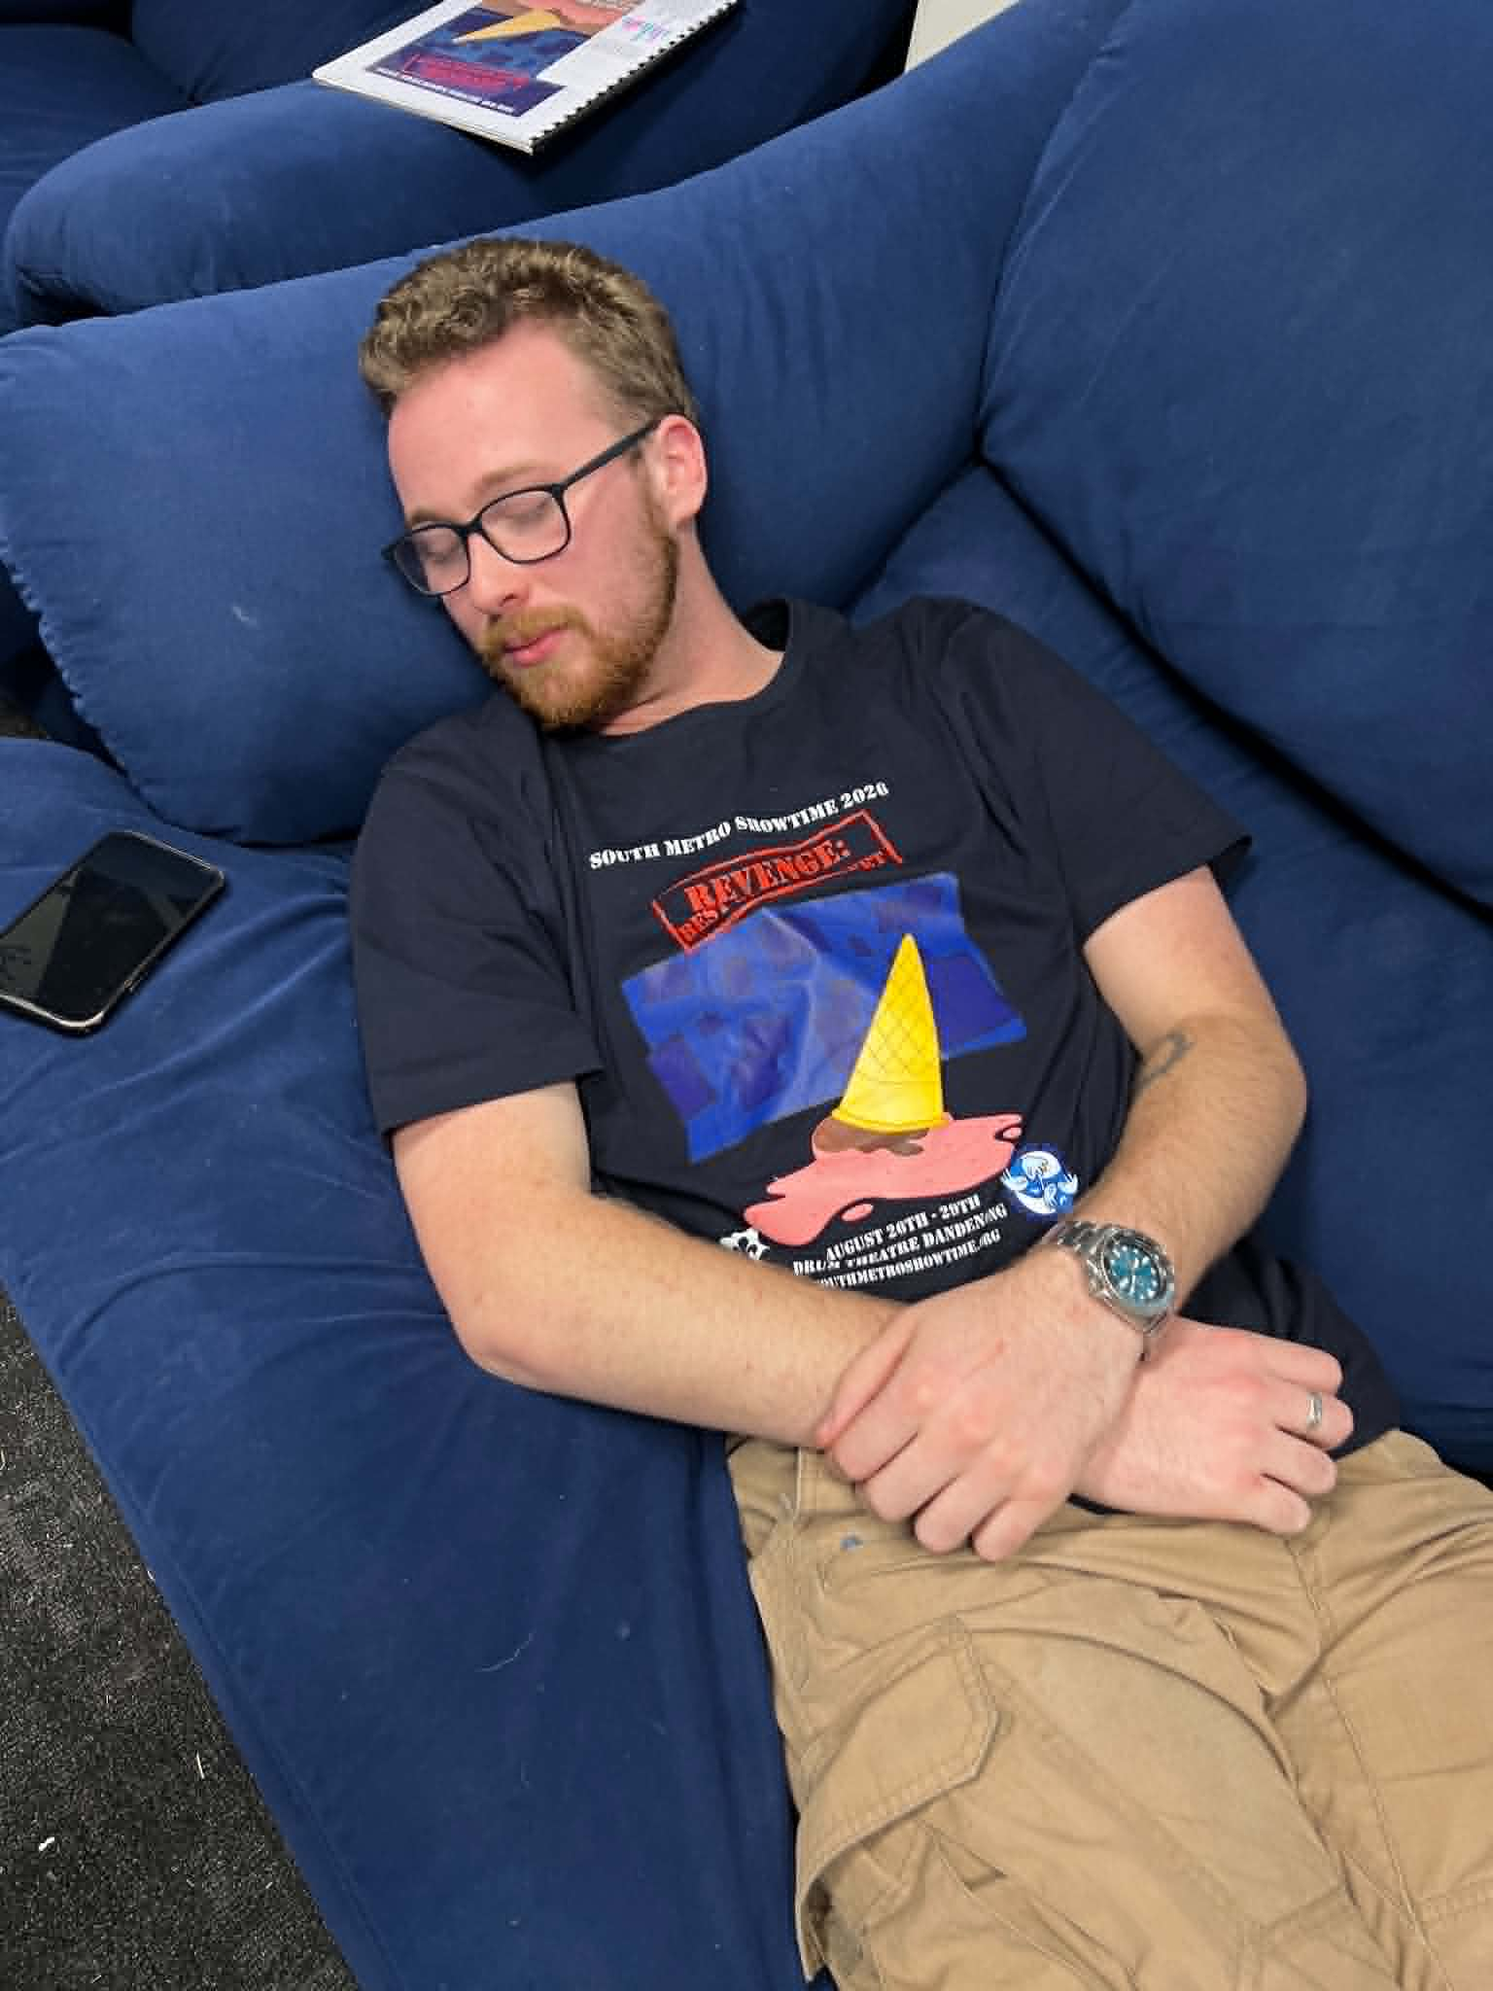
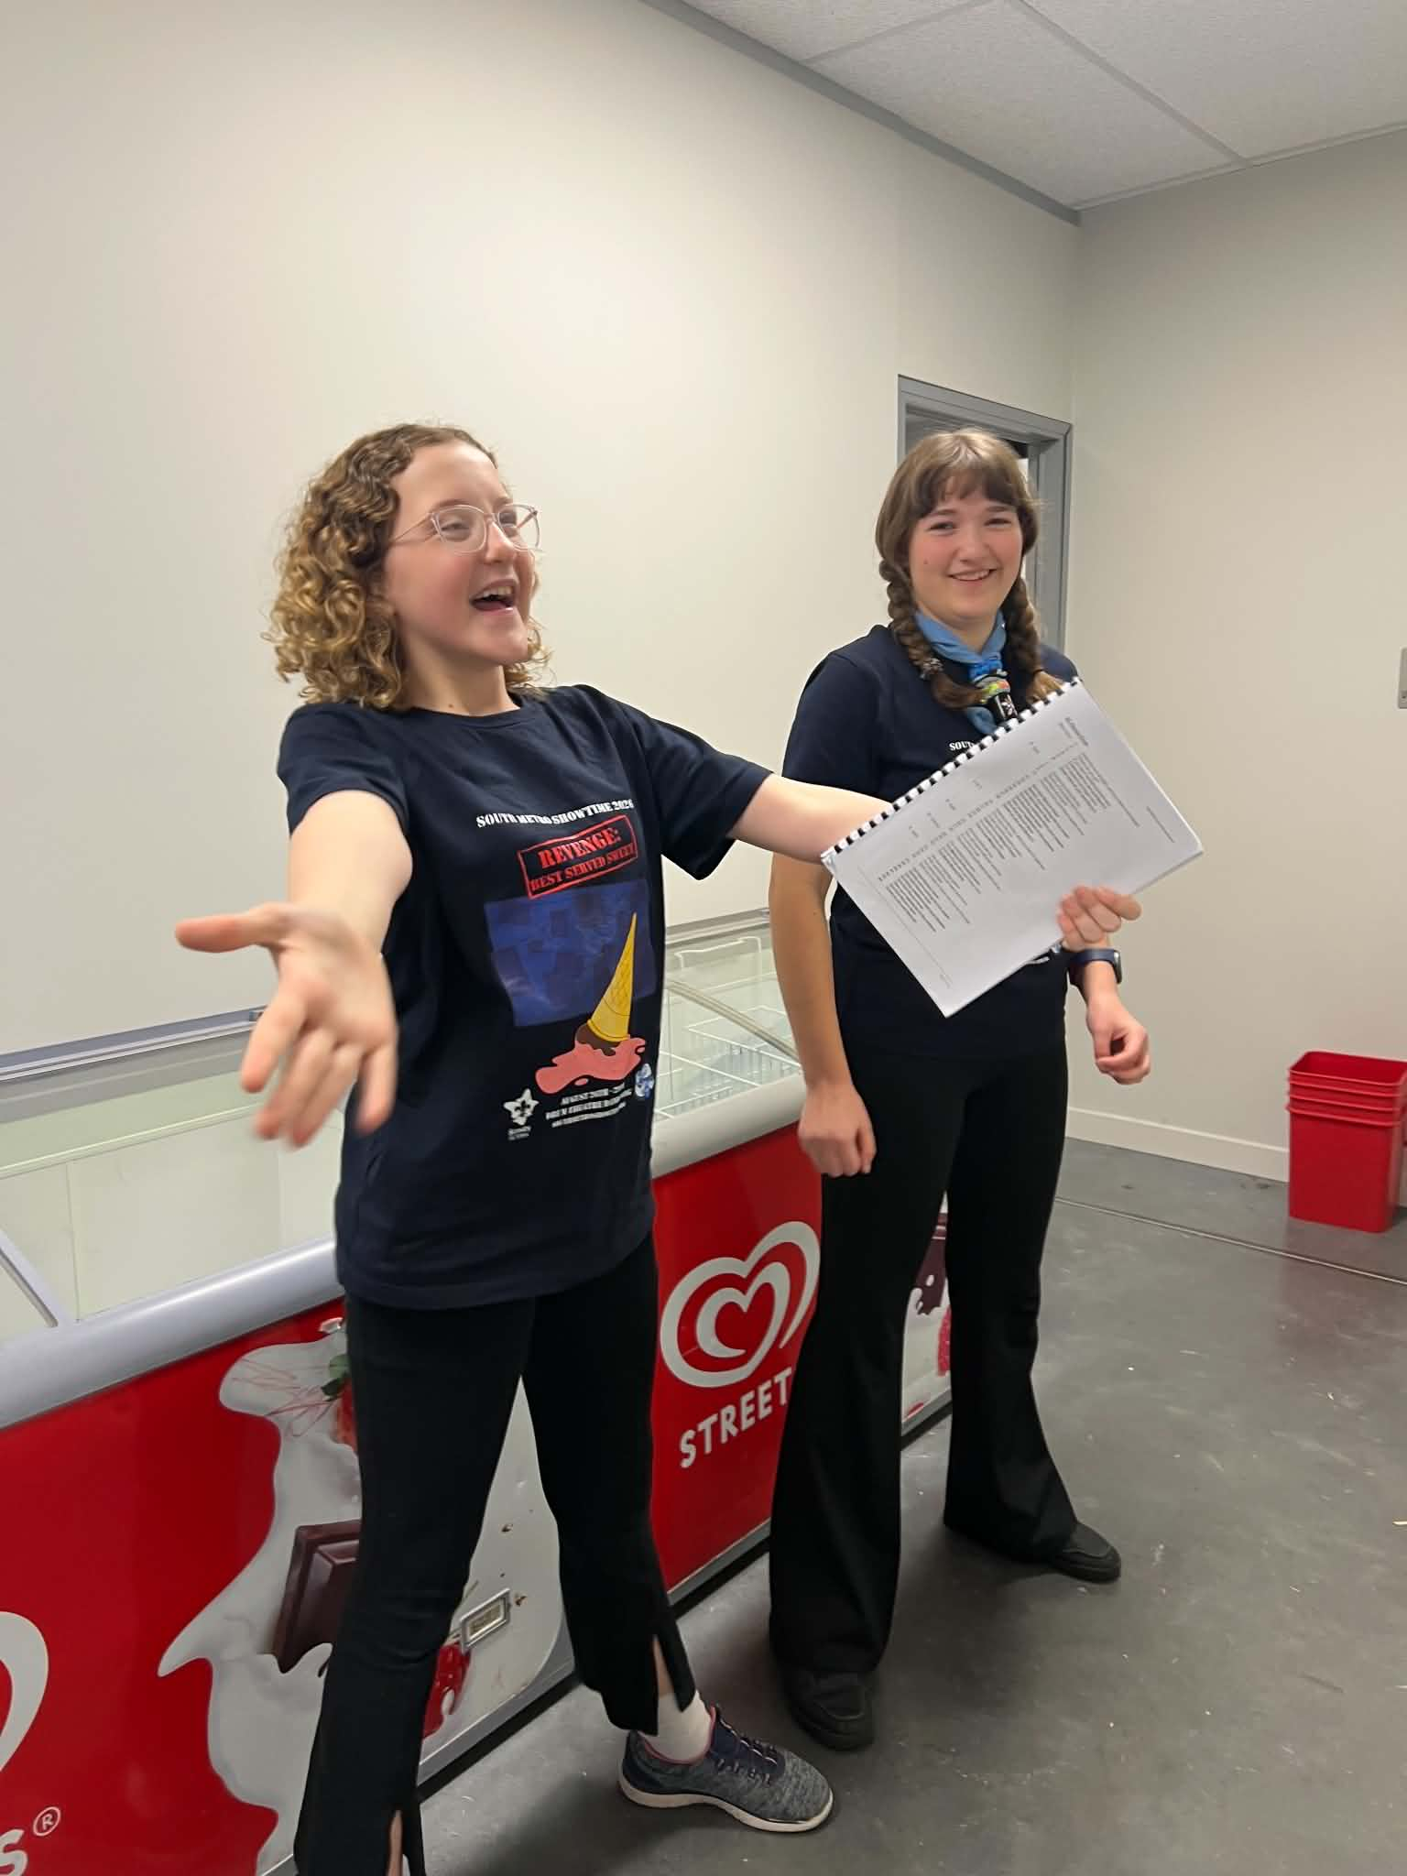

🎭 Centre Stage Advice from the PLs 🎭
A message from our Patrol Leaders sharing tips, reflections, and inspiration from their Showtime journey.

🌟 Toby – Forum Patrol Leader 🌟
Once we’ve covered certain items a few times in rehearsal, we may not continue running them every week. This isn’t because they’re not important — it’s because we need to move on and learn the rest of the show.
That means it’s really important that everyone takes responsibility for revising these items at home.

Please make sure you’re regularly visiting the Members’ Section of the website and practising all songs and dances we’ve learnt so far. This will help you feel confident, prepared, and ready when we bring everything together in rehearsals.

🎭Black Base Layer Reminder
All cast members are required to supply and bring their own black base layer to rehearsals and performances.
This base layer must:
- Cover at least as much as a singlet top
- Include bike shorts (to mid-thigh length)

Need support during rehearsals?
Our awesome Support Team is always around if you need anything. You can also get in touch with our
Support Manager Shelley Brown, at support@southmetroshowtime.org.

