🎟️ TICKETS ON SALE NOW! 🎭
South Metro Showtime presents… ✨ REVENGE: Best Served Sweet✨
It’s official — tickets are now available for our 2026 show at the Drum Theatre, Dandenong!
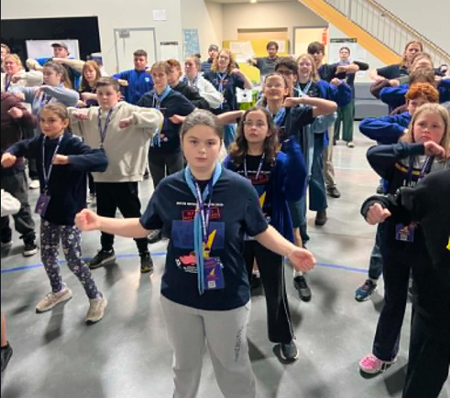
Visit www.southmetroshowtime.org or call (03) 8571 1666 to book now!

🎭 Rehearsal Recap
Tonight we had a jam packed rehearsal going over our dance moves and singing for Creatures of The Night and Household Hallelujah. We then brought the energy and learnt New Flash.
Keep up the energy and the positive vibes see you all next week.
Written by Teagan
Next Rehearsal
🗓️ Date: Sunday 19th July 2026 (Photo day)
🕔 Time: 1:00pm to 6:00pm
📍 Venue: 1st Carrum Downs (Rehearsal Venue)
💼 Please bring your Script, Pen, Water Bottle and Lanyard with name tag.
Duty Patrols:
Regent(Opening) - Her Majesty’s (Closing)
Members in these patrols will need to arrive 10 mins earlier to set up and stay back to pack up (approx 10 mins).
Running late? Unwell? Can’t make it? Please text Stabby on 0432 285 154

Thank You for Supporting Our Bunnings BBQ Fundraiser!

A huge thank you to all our parents, South Metro Showtime members, and community supporters who helped make our Bunnings BBQ Fundraiser on Sunday 28th June such a success.

Whether you volunteered your time, helped behind the scenes, purchased a sausage, or shared our fundraiser, we truly appreciate your support. It was a fantastic team effort from our Showtime community.

Thanks to everyone's generosity, we raised an incredible $2,000! 🎉

These funds help support the running of South Metro Showtime and keep costs as affordable as possible for our families while continuing to provide an amazing experience for our cast and crew.

Thank you for helping make Showtime possible! ❤️

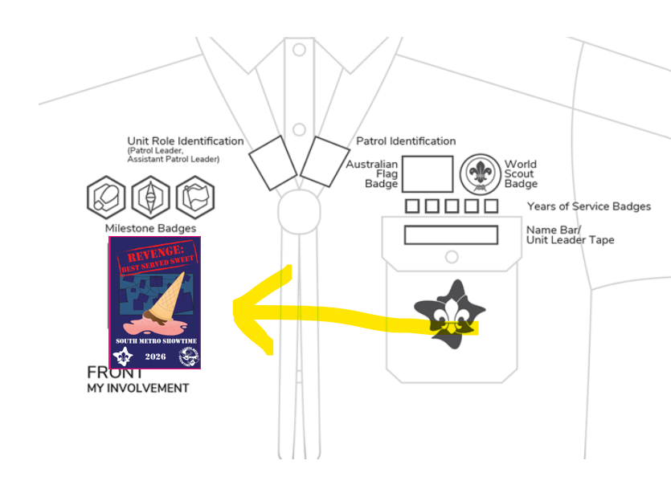
🎉 SMST Show Badges

🎭 The SMST Show Badge is a special event badge that celebrates your involvement in South Metro Showtime 2026:
REVENGE: BEST SERVED SWEET
The Showtime Show badges were handed out this week at rehearsals. If you were absent, please see Kate or
Stabby at the next rehearsal.

Scouts: The show badge is considered an event badge and should be worn under the Milestones section on the front of your uniform shirt.

Guides:
Guides 10-14 yrs wearing blue and orange polo and sash. Badge is sewn on the front of the sash right under the patrol emblem badge.

Guides 14-17 yrs wearing either navy and orange polo or formal blue shirt. Badge is sewn directly onto the shirt on the right side 5cm below the collar. No sash to be worn with 14+ uniform shirts.

Please speak to the Guide Liaison Cat if you have any questions
📸 Showtime Cast Photos – Sunday 19th July
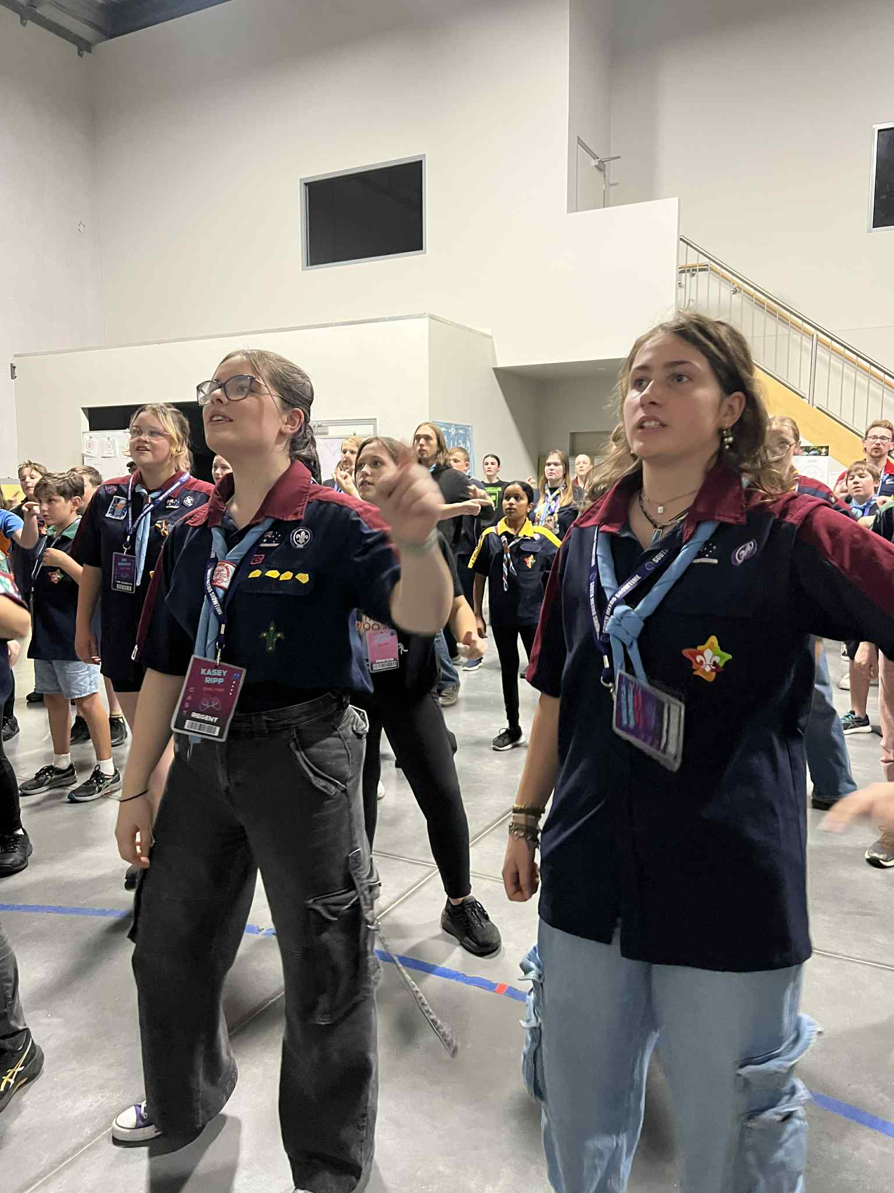
We’ll be taking official cast photos during rehearsal on Sunday 19th July (Day Rehearsal), so please either wear or bring along (to change into) your full Scout or Guide uniform. These photos are a great keepsake and will be featured in our program and promotional materials — so let’s look our best!
Please make sure you start preparing your full uniform now.
Please make sure your show badge is on your uniform.
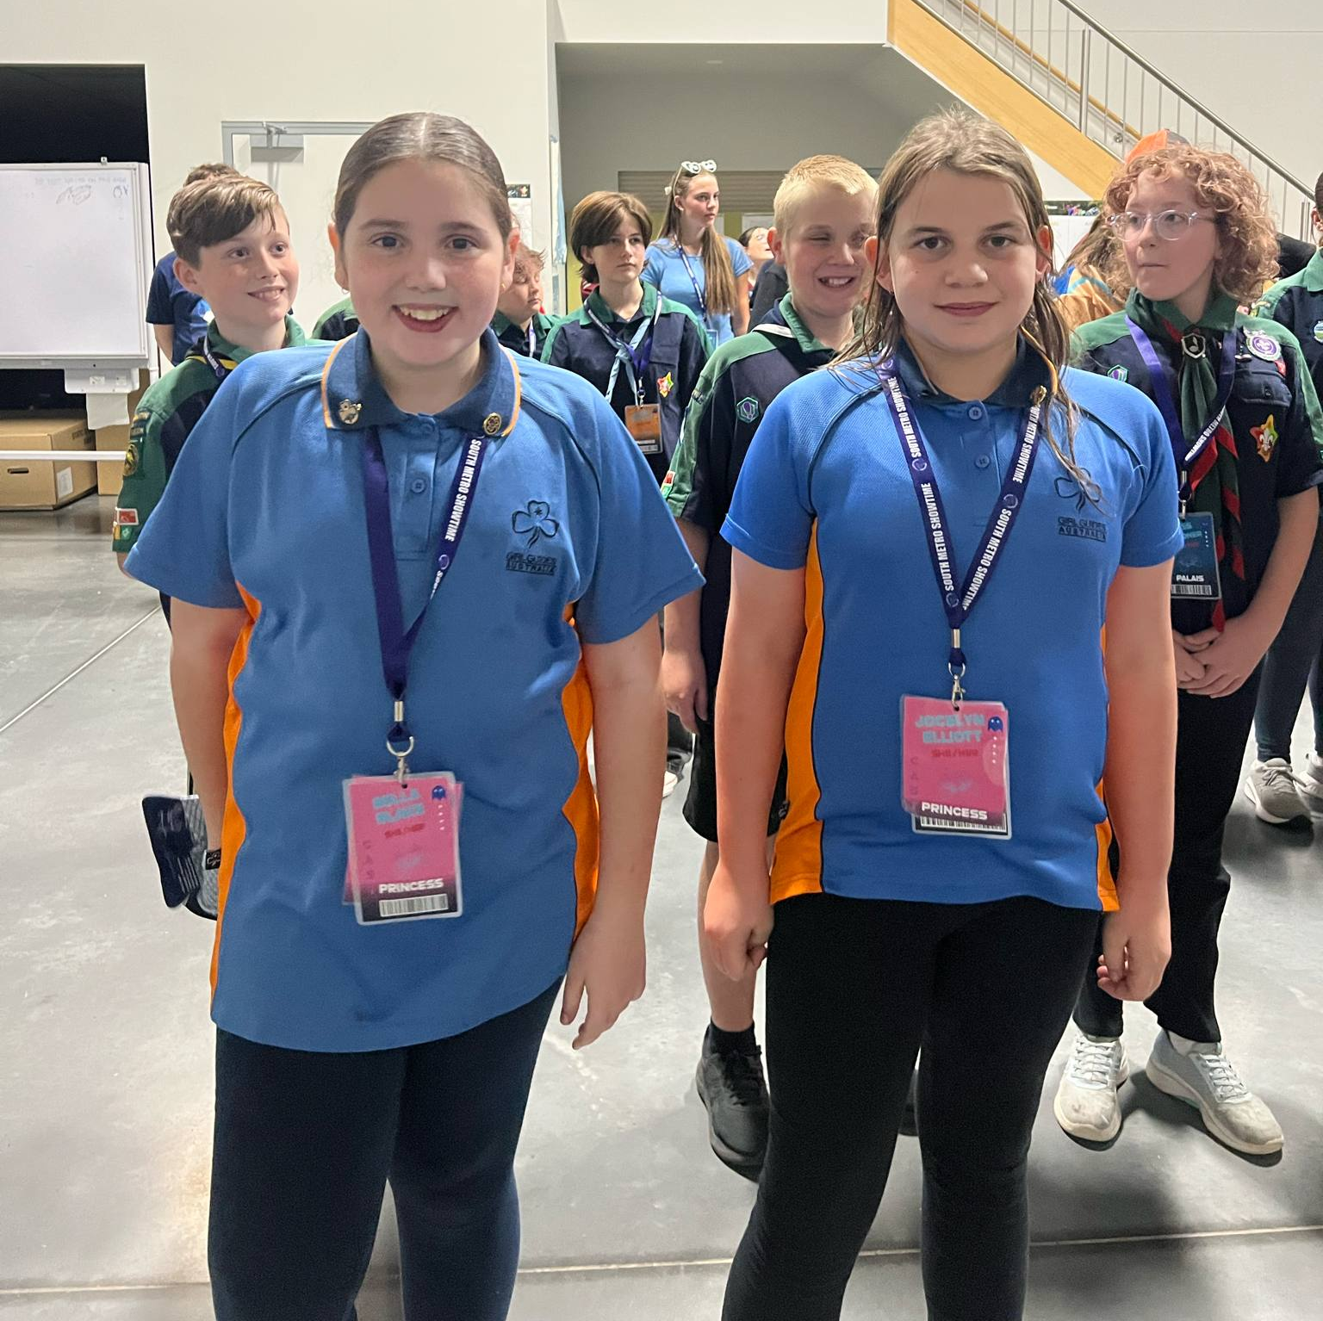
For Scouts, full uniform includes:
- Scout shirt
- Scout scarf
- Navy blue trousers
Dress pants or school uniform pants please.
Trackpants, Jeans, leggings or shorts are not permitted -
The Costumes team have provided these to all junior cast and will bring them to photos.
- Scout belt (Tip: Ask around your home unit to borrow for Photos and show week or purchase from Scout Shop online)
For Guides, full uniform includes:
Age 10-14: Youth Tween Polo shirt (blue and orange), and Sash (with badges sewn in correct position)
Age 14-17: Youth Teen formal blue shirt is preferable with appropriate metal badges or Teen Polo shirt (navy and orange), NO sash for 14-17 members.
All of the above should be worn with plain navy slacks/pants/culottes/skirt and Showtime scarf.
🎭 This is also the uniform you’ll wear on stage for Finale during the show run, so it’s a great chance to make sure everything fits and is ready!
📷 A whole group photo featuring the entire Showtime team — including all our amazing departments like costumes, mics, shonkys, support etc. — will be taken at 5:00pm. Don’t miss it!
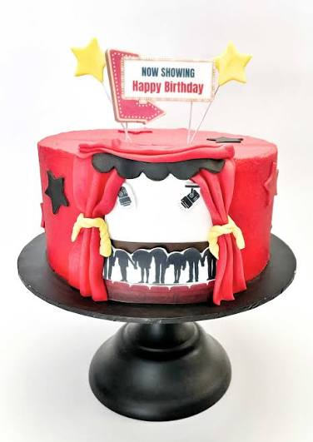
Birthday Shoutouts!
A huge shout out and Happy Birthday to the following SMST Members who are celebrating their birthday this week:
- Mitchell Dickson (Comedy)
Wishing all our SMST members a birthday filled with laughter, fun and lots of cake!

🧥 SMST Merch Store! Now Open
Want to rep Showtime in style and stay warm this winter? Our royal blue SMST zip-up hoodies are now available to pre-order through our online webstore! And now we’ve got Beanies too!
These are an optional extra and perfect for rehearsals, school, or just showing your Showtime pride out and about.
For Hoodies, once we receive 20 orders, the batch will be processed — so encourage your castmates to get on board too! Beanies are in stock right now!
🛒 Order now at:
https://shop.fullypromoted.com.au/south-metro-showtime
Please note the following,
- The first time you use the link, DON’T TRY TO CREATE A USER OR LOGIN
- Place the order for the items.
- When you go to check out fill out all the details
- At the end it will ask you to enter the password
- This will automatically create you a login
You can use this login to check what you have ordered in the past and make further orders after your first order 💙 Look sharp, stay cosy, and show off that Showtime spirit!

👕 Costume Requirements – Cast Supplied Items 👖
As we continue preparing costumes for the show, there are a few items that cast members will need to supply themselves.

🛒 Flavour Fever – Those casted as “Shop Goers”
- Bright coloured T-shirt (no logos)
- Blue jeans

📰 News Flash – Those casted as “General Public”
- Bright coloured T-shirt (no logos)
- Blue jeans
💡 If you are performing in both Flavour Fever and News Flash, you may wear the same T-shirt and jeans for both items.

🏠 Sold, Sold, Sold – Those casted as “Buyers”
- Button-up shirt or blouse
- Tidy/neat pants or a knee-length skirt
Please start looking for these items now so that costumes can check they are suitable well before show time.
If you have any difficulty sourcing any of the required items, please speak with the Costumes Team. We're happy to help and work with you to find a solution.
Thank you for helping bring our characters to life on stage! 🎭

Countdown to Theatre: 42 Days
(as of 12th July 2026)

🧠🎉 Book Now – South Metro Showtime Trivia Night 2026! 🎉🧠

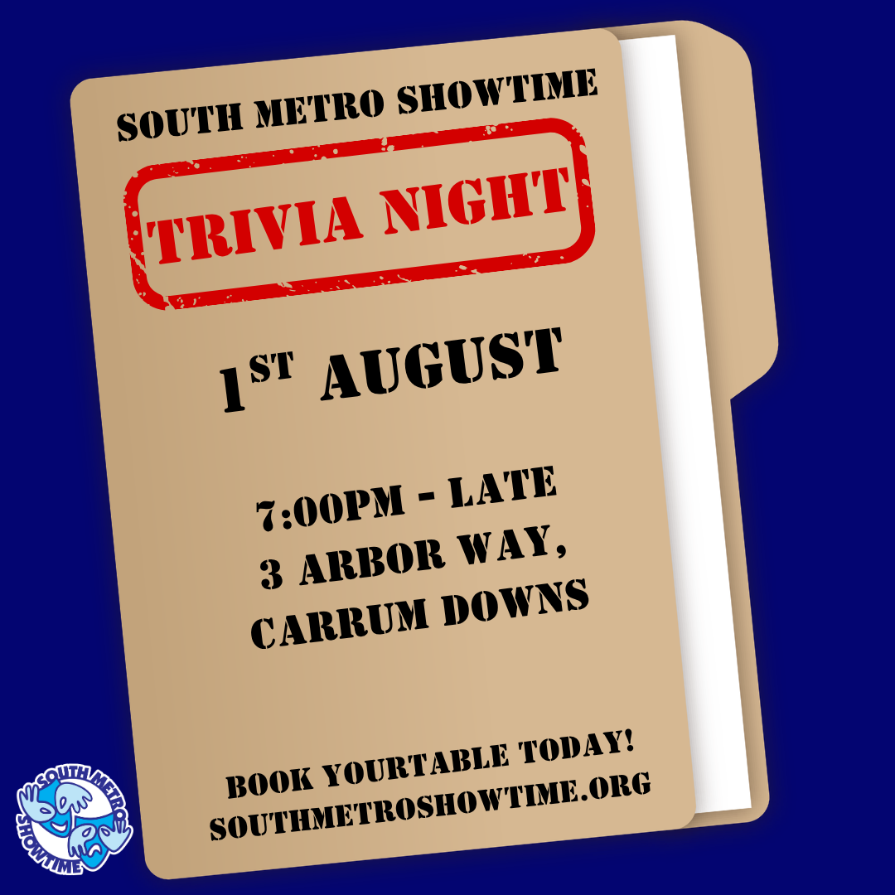
The countdown is on! Gather your family, friends, Scout or Guide unit, workmates, and neighbours for one of the biggest fundraising events of the year.

Our South Metro Showtime Trivia Night is back, and this year's event will help support our 2026 production,
Revenge: Best Served Sweet!

📅 Saturday 1st August 2026
🕖 Doors Open: 7:00pm
❓ Trivia Starts: 7:15pm

📍 1st Carrum Downs Scout Hall
3 Arbor Way, Carrum Downs VIC 3201
Please park in Clifton Grove and surrounding streets.

💲 Tickets

$15 per person (pre-sale)

$20 per person at the door

🎟️ Book now: https://www.trybooking.com/DNJRE

Whether you're a trivia master or just looking for a great night out, everyone is welcome! Book as an individual or reserve a whole table for your team.

When booking through TryBooking, simply enter your team name or let us know who you'd like to sit with, and we'll make sure you're seated together.

Don't have a team? No worries! Book your ticket anyway and we'll match you with a team on the night, so everyone can join in the fun.

Expect a night full of trivia, games, prizes, raffles, laughter, and plenty of friendly competition—all while helping bring Revenge: Best Served Sweet! to the stage.

We can't wait to see who will be crowned our 2026 Trivia Champions! 🏆

🎭 Patrol Mini-Challenges Are ON!
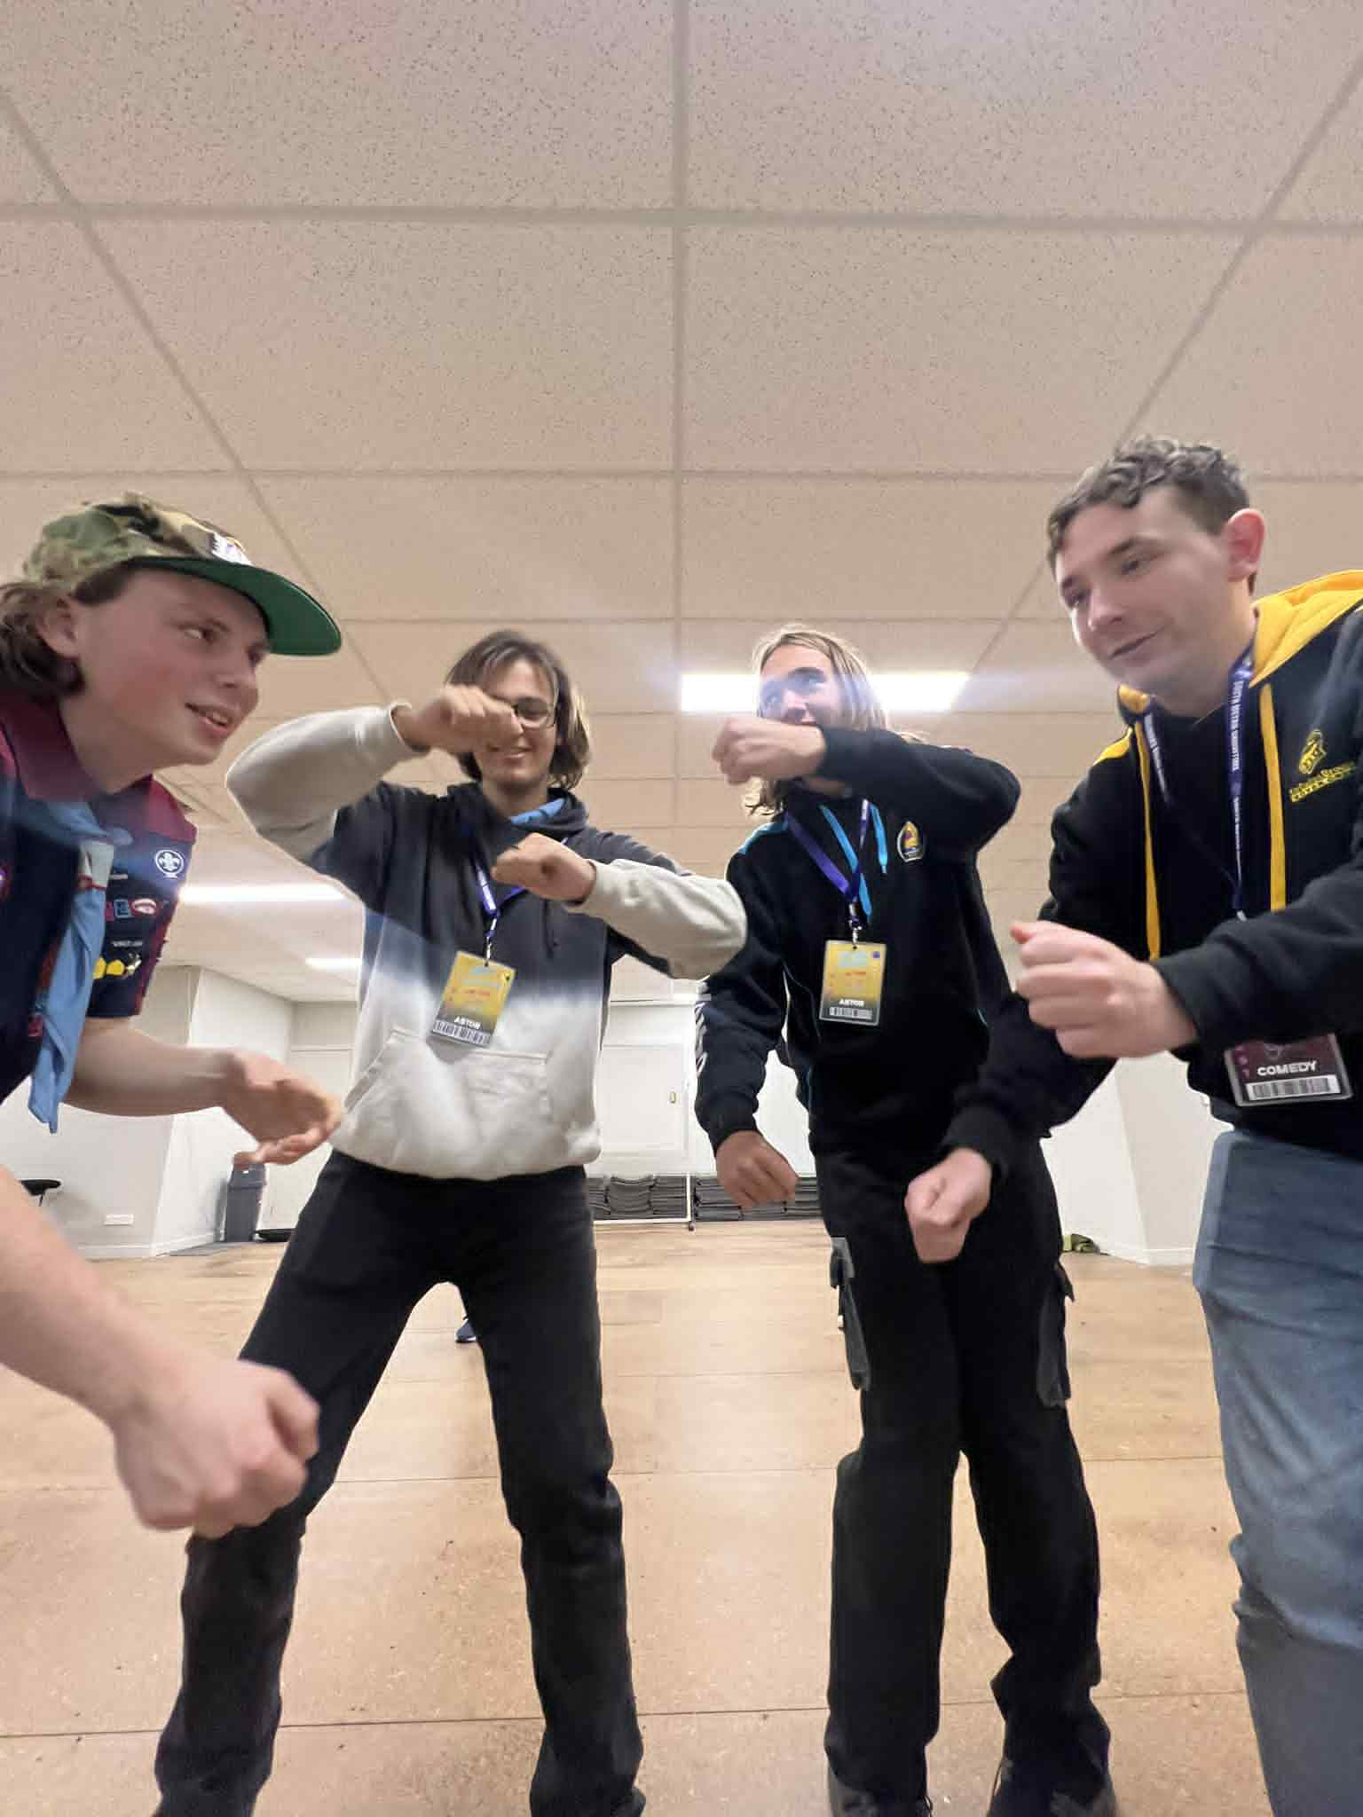
Hey Cast!
Now’s the perfect time to get stuck into your Patrol Mini-Challenges and earn points to help your Patrol claim victory in 2026! Whether you’re snapping pics, teaching songs, or rocking your show shirt out and about — every little bit counts!
Here are some of the ways you can earn those precious Patrol Points:
🖼 Poster Challenge – We’re all going to Showtime!
Take a photo with a South Metro Showtime poster up at your Scout or Guide Hall.
🎯 Bonus points if your whole unit is in the photo!
🧠 Trivia Night 2026 – Represent your patrol!
Everyone that comes to Trivia night will get to choose a patrol to give a token to. The patrol with the most tokens will get 5 Extra points.
🎟 Ticket Sales – I’m bringing EVERYONE to Showtime!
Sell 5 tickets and earn 10 points!
Bring your friends, family, unit... your whole group if you can!
👕 Wear Your Show Shirt in Public – I’m Proud to be a Showtimer!
Snap a photo wearing your Revenge: Best Served Sweet! shirt out in public — at the shops, school, park… wherever!
📹 Submit a Rehearsal Video – Practice Makes Perfect!
Send in a video of you rehearsing your lines. Bonus points for big smiles and strong projection!
🎶 Teach a Song – Everyone Could Be a Showtimer!
Teach a family member one of our show songs — it’ll help you remember it too!
🧀 Cheese Awards – For Being All-Round Awesome!
These are given to cast members who bring energy, positivity, and all-round Showtime spirit to everything they do.
👉 Send all your challenge photos and videos to Jeff (Michael Watts) at:
📧 cast.experience@southmetroshowtime.org
Let’s keep the fun going between rehearsals and keep working towards that Patrol Challenge Victory! 🏆💙

📅 Save the Date – Weekend Rehearsal & Cast Sleepover!
Mark your calendars! Our 2026 Weekend Rehearsal & Cast Sleepover will be held on Saturday 8th & Sunday 9th August.
This is one of the biggest weekends on the Showtime calendar, where we'll spend extra time rehearsing, getting to know our Patrols, practising our scarf presentations, and having plenty of fun together. It's a fantastic opportunity to build friendships and create the incredible Showtime spirit that makes our productions so special. More information, including times, what to bring, and other important details, will be released in the coming weeks, so stay tuned!
🍰 What Dessert Am I? - Quiz Question 🤔

I may look simple, but I am known for being tricky to create. I was born in France, and my name comes from a word meaning “crunch” or “crackle”. I am made from choux pastry, filled with delicious cream, and often built into a tall tower held together with caramel. Who am I?
What am I? 🍰

