🎟️ TICKETS ON SALE NOW! 🎭
South Metro Showtime presents… ✨ REVENGE: Best Served Sweet✨
It’s official — tickets are now available for our 2026 show at the Drum Theatre, Dandenong!
Visit www.southmetroshowtime.org or call (03) 8571 1666 to book now!

🎭 Rehearsal Recap
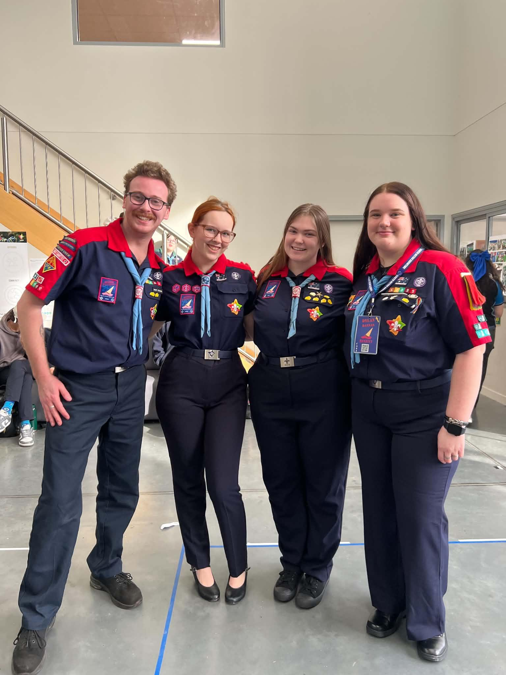
Today at rehearsal every patrol got their photo taken and looked amazing!
Thanks to everyone for making a special effort with your uniforms.
We learnt the Pre-Finale Cherry on Top and finished off Household Hallejullah. Pat ran a special patrol challenge in which patrols choreographed a dance to present to the Production Team. The Showtime family all came together for the Group Photo.
Written by Breanne
Next Rehearsal
🗓️ Date: Sunday 26th July 2026
🕔 Time: 5:45pm to 8:30pm
📍 Venue: 1st Carrum Downs (Rehearsal Venue)
💼 Please bring your Script, Pen, Water Bottle and Lanyard with name tag.
Running late? Unwell? Can’t make it? Please text Stabby on 0432 285 154

Duty Patrols:
Palais (Opening) - Forum (Closing)
Members in these patrols will need to arrive 10 mins earlier to set up and stay back to pack up (approx 10 mins).
Special Rehearsal - Toybox Takedown (4:30pm)
The following Cast members are required for a special rehearsal at 4:30pm:
Lara W | Aya B | Connor S | Laura A | Ruby B | Kasey R | Bronwyn P
Noah B

Picture tells 1000 Words (5:00pm)
The following Cast members are required for a special rehearsal at 5:00pm:
Abby W | Toby S | Pepper K | Nicole G | Lucy R

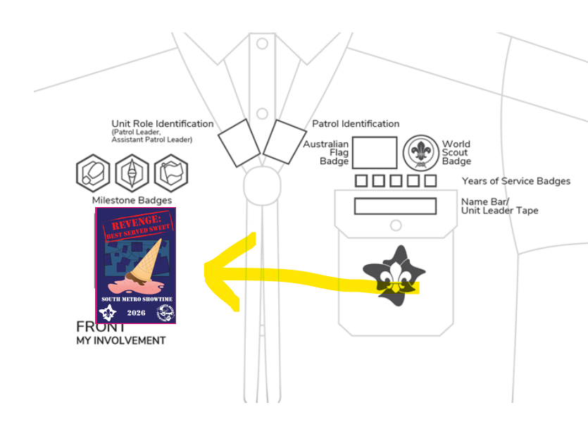
🎉 SMST Show Badges

🎭 The SMST Show Badge is a special event badge that celebrates your involvement in South Metro Showtime 2026:
REVENGE: BEST SERVED SWEET
The Showtime Show badges were handed out this week at rehearsals. If you were absent, please see Kate or
Stabby at the next rehearsal.

Scouts: The show badge is considered an event badge and should be worn under the Milestones section on the front of your uniform shirt.

Guides:
Guides 10-14 yrs wearing blue and orange polo and sash. Badge is sewn on the front of the sash right under the patrol emblem badge.

Guides 14-17 yrs wearing either navy and orange polo or formal blue shirt. Badge is sewn directly onto the shirt on the right side 5cm below the collar. No sash to be worn with 14+ uniform shirts.

Please speak to the Guide Liaison Cat if you have any questions

🎭 Weekend Rehearsal & Sleepover – What You Need to Know!
The excitement is building as we head into one of the biggest weekends on the South Metro Showtime calendar before Theatre! On the weekend of August 8–9, cast members will participate in a full rehearsal, overnight sleepover, and a very special tradition on Sunday – the Scarf Presentation!
To ensure sufficient sustenance, we ask that in the lead up to weekend rehearsal each cast member brings $10 to further cover meals and snacks for that weekend. This can be $10 Cash handed to a member of the admin team or a direct deposit into the South Metro Bank Account (Please put cast members name as the reference). BSB: 633-000 Acc No. 149350431

🕐 Rehearsal & Sleepover Timeline
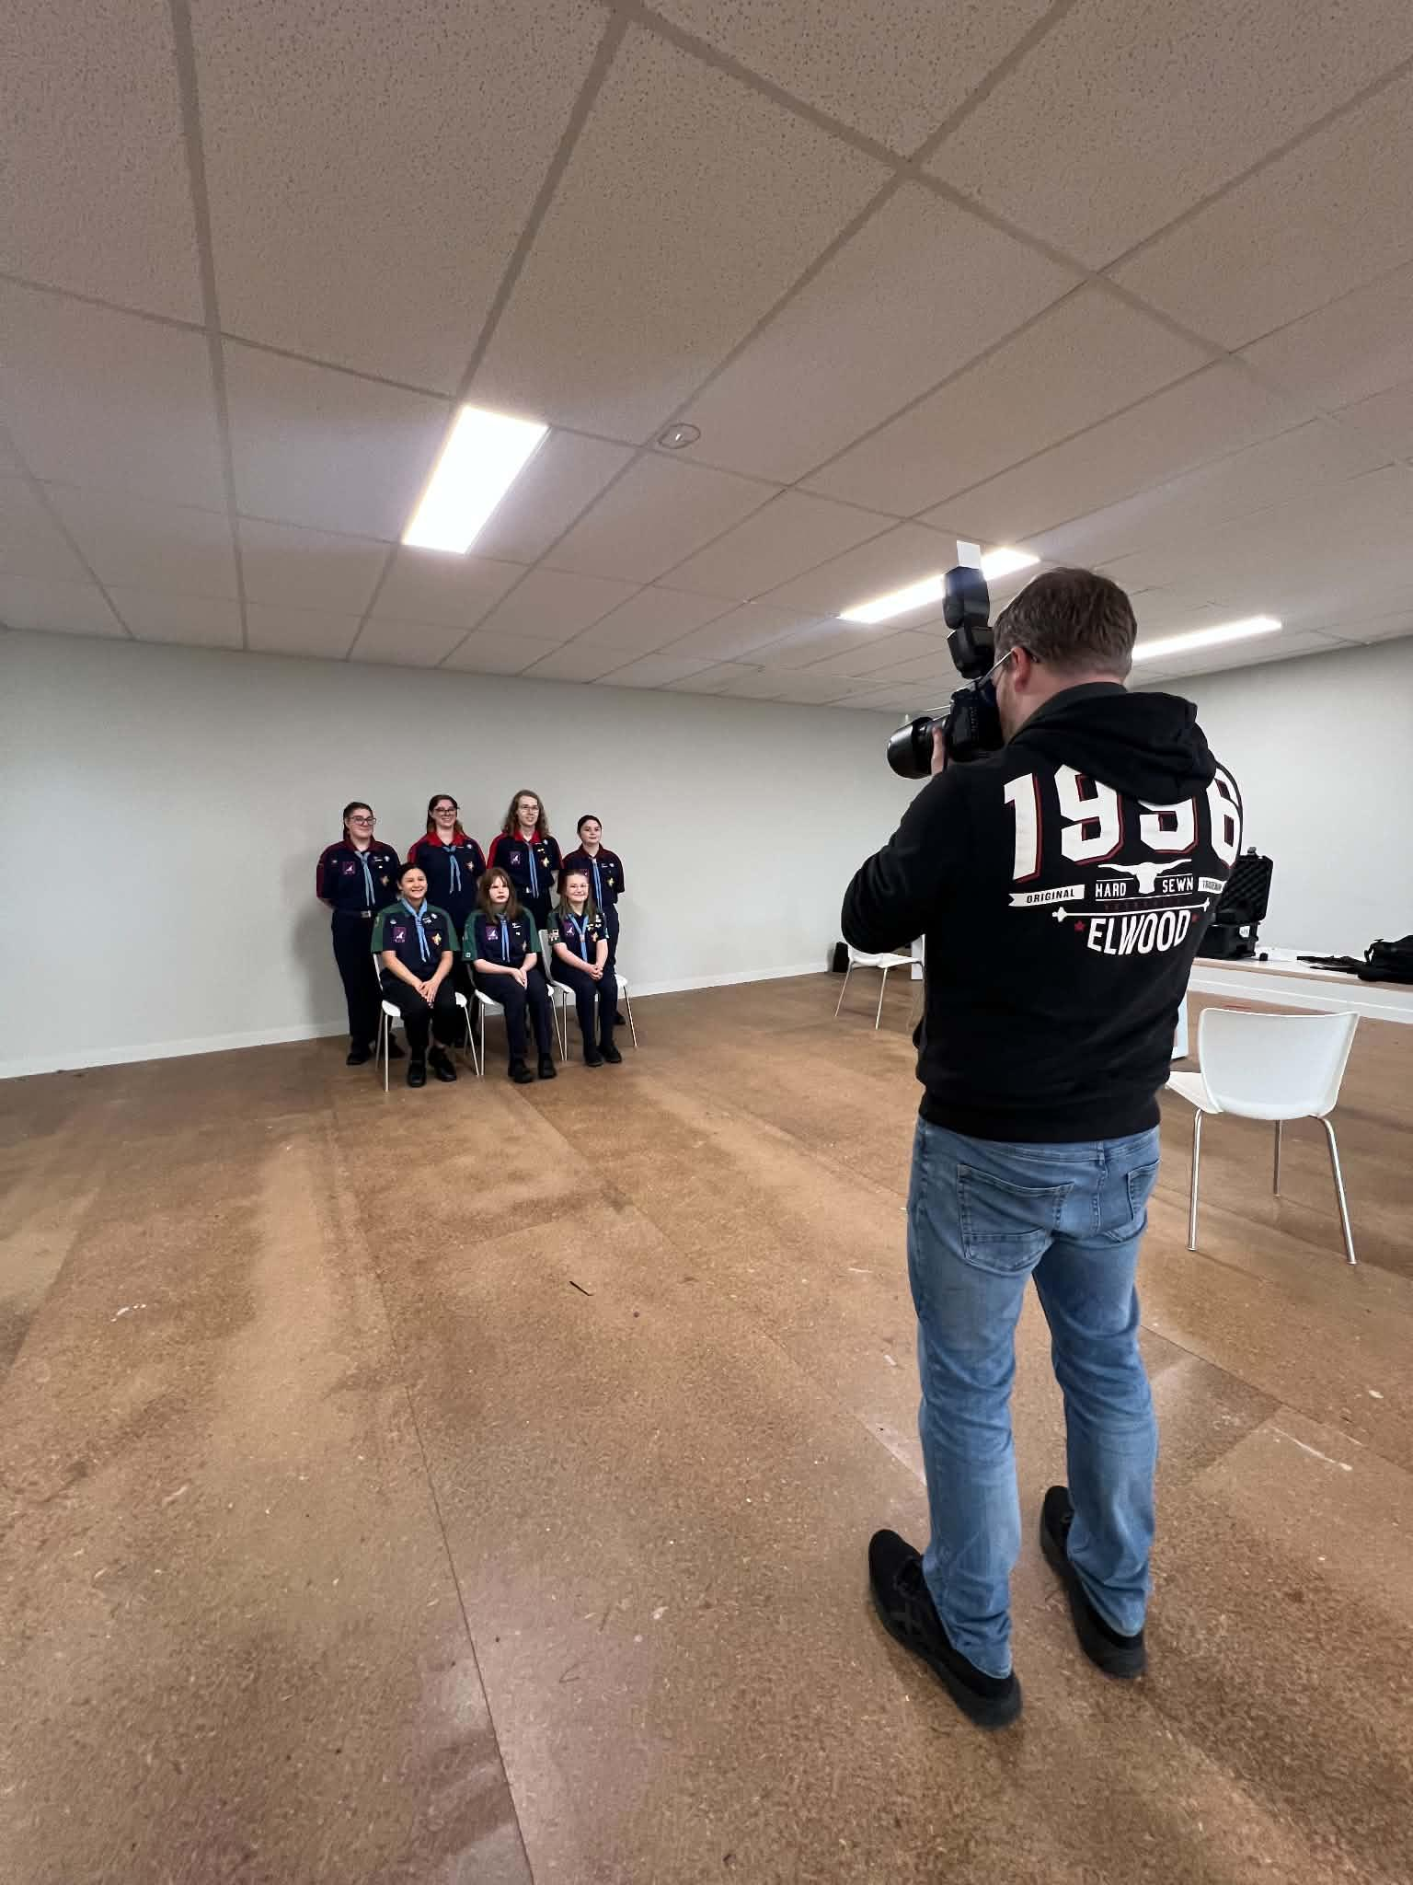
Saturday, August 8
- Rehearsal: 1:00pm – 9:00pm
- Location: Arbor Way, Carrum Downs (our usual rehearsal space)
- Dinner: Provided onsite
After rehearsal, patrols will head to their designated sleepover locations:
- Her Maj, Palais, Phoenix, Princess & Regent will remain at the rehearsal hall for the evening.
- Astor, Forum and Comedy will travel to Moodemere Scout Hall, Noble Park for their overnight stay.

Each location will be supported by at least two adult leaders of the Showtime Team, ensuring a safe, fun, and well-supervised environment.
Sunday, August 10
- Patrols who stayed at Moodemere Scout Hall will return to the
rehearsal hall between 8:15am - 8:30am
- Breakfast & Lunch will be provided for all cast members at the rehearsal hall.
- Scarf Presentation will be at 3:00pm
(Parents, Families and Scouting members are invited to attend)
- Rehearsal finishes at 5:00pm

Birthday Shoutouts!
A huge shout out and Happy Birthday to the following SMST Members who are celebrating their birthday this week:
- Olivia Wingfield (Princess)
- Shea Baillie (Phoenix)
Wishing all our SMST members a birthday filled with laughter, fun and lots of cake!



🧥 SMST Merch Store! Now Open
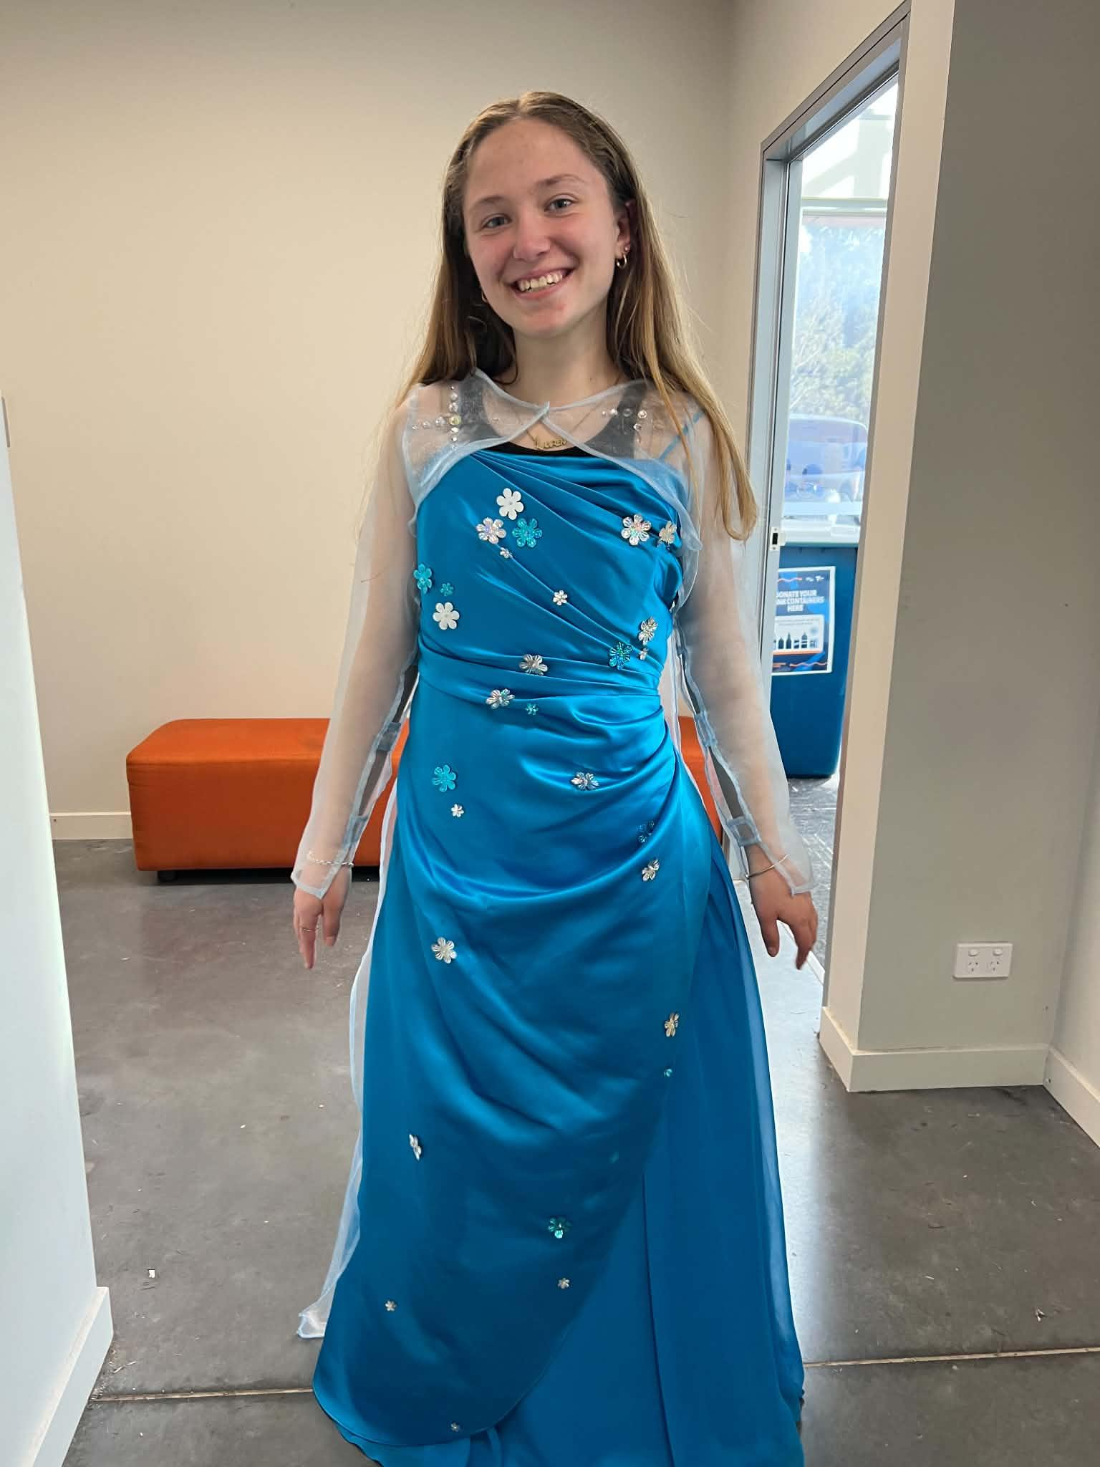
Want to rep Showtime in style and stay warm this winter? Our royal blue SMST zip-up hoodies are now available to pre-order through our online webstore! And now we’ve got Beanies too!
These are an optional extra and perfect for rehearsals, school, or just showing your Showtime pride out and about.
For Hoodies, once we receive 20 orders, the batch will be processed — so encourage your castmates to get on board too! Beanies are in stock right now!
🛒 Order now at:
https://shop.fullypromoted.com.au/south-metro-showtime
Please note the following,
- The first time you use the link, DON’T TRY TO CREATE A USER OR LOGIN
- Place the order for the items.
- When you go to check out fill out all the details
- At the end it will ask you to enter the password
- This will automatically create you a login
You can use this login to check what you have ordered in the past and make further orders after your first order 💙 Look sharp, stay cosy, and show off that Showtime spirit!

Countdown to Theatre: 35 Days
(as of 19th July 2026)
🍰 What Dessert Am I? - Quiz Question 🤔

I originated in Italy, but I'm loved all over the world. My name means "pick me up" because I'm made with coffee. I'm layered with sponge biscuits, creamy mascarpone, and a dusting of cocoa on top. I don't usually need to be baked.

What am I? 🍰

🧠🎉 Book Now – South Metro Showtime Trivia Night 2026! 🎉🧠

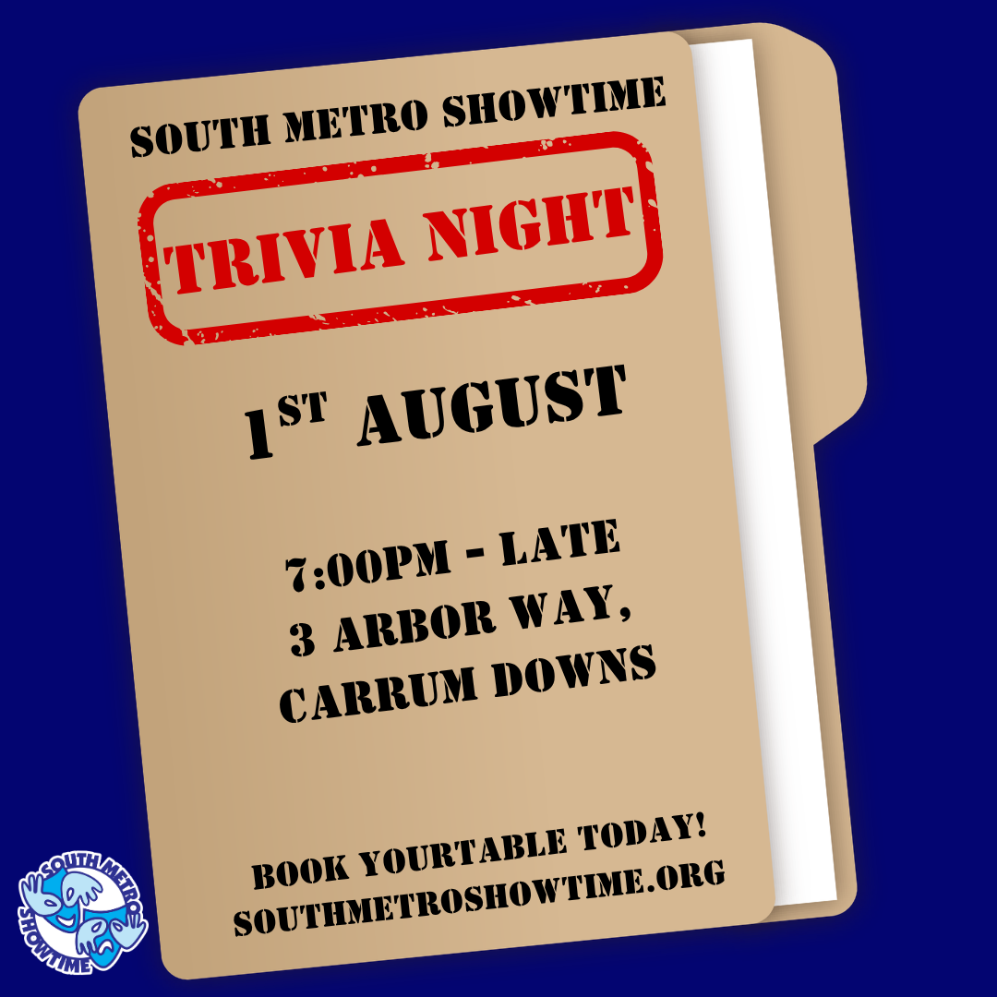
The countdown is on! Gather your family, friends, Scout or Guide unit, workmates, and neighbours for one of the biggest fundraising events of the year.

Our South Metro Showtime Trivia Night is back, and this year's event will help support our 2026 production,
Revenge: Best Served Sweet!

📅 Saturday 1st August 2026
🕖 Doors Open: 7:00pm
❓ Trivia Starts: 7:15pm

📍 1st Carrum Downs Scout Hall
3 Arbor Way, Carrum Downs VIC 3201
Please park in Clifton Grove and surrounding streets.

💲 Tickets

$15 per person (pre-sale)

$20 per person at the door

🎟️ Book now: https://www.trybooking.com/DNJRE

Whether you're a trivia master or just looking for a great night out, everyone is welcome! Book as an individual or reserve a whole table for your team.

When booking through TryBooking, simply enter your team name or let us know who you'd like to sit with, and we'll make sure you're seated together.

Don't have a team? No worries! Book your ticket anyway and we'll match you with a team on the night, so everyone can join in the fun.

Expect a night full of trivia, games, prizes, raffles, laughter, and plenty of friendly competition—all while helping bring Revenge: Best Served Sweet! to the stage.

We can't wait to see who will be crowned our 2026 Trivia Champions! 🏆

🎭 Patrol Mini-Challenges Are ON!
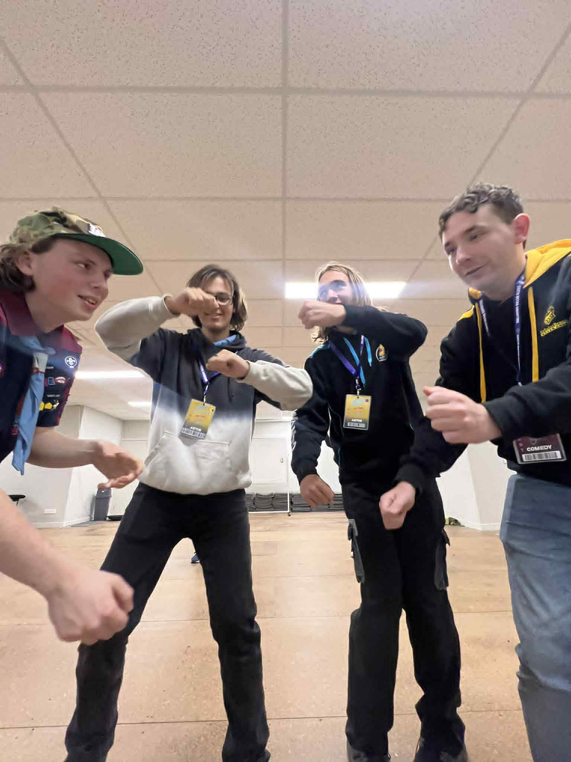
Hey Cast!
Now’s the perfect time to get stuck into your Patrol Mini-Challenges and earn points to help your Patrol claim victory in 2026! Whether you’re snapping pics, teaching songs, or rocking your show shirt out and about — every little bit counts!
Here are some of the ways you can earn those precious Patrol Points:
🖼 Poster Challenge – We’re all going to Showtime!
Take a photo with a South Metro Showtime poster up at your Scout or Guide Hall.
🎯 Bonus points if your whole unit is in the photo!
🧠 Trivia Night 2026 – Represent your patrol!
Everyone that comes to Trivia night will get to choose a patrol to give a token to. The patrol with the most tokens will get 5 Extra points.
🎟 Ticket Sales – I’m bringing EVERYONE to Showtime!
Sell 5 tickets and earn 10 points!
Bring your friends, family, unit... your whole group if you can!
👕 Wear Your Show Shirt in Public – I’m Proud to be a Showtimer!
Snap a photo wearing your Revenge: Best Served Sweet! shirt out in public — at the shops, school, park… wherever!
📹 Submit a Rehearsal Video – Practice Makes Perfect!
Send in a video of you rehearsing your lines. Bonus points for big smiles and strong projection!
🎶 Teach a Song – Everyone Could Be a Showtimer!
Teach a family member one of our show songs — it’ll help you remember it too!
🧀 Cheese Awards – For Being All-Round Awesome!
These are given to cast members who bring energy, positivity, and all-round Showtime spirit to everything they do.
👉 Send all your challenge photos and videos to Jeff (Michael Watts) at:
📧 cast.experience@southmetroshowtime.org

