🎭 Rehearsal Recap
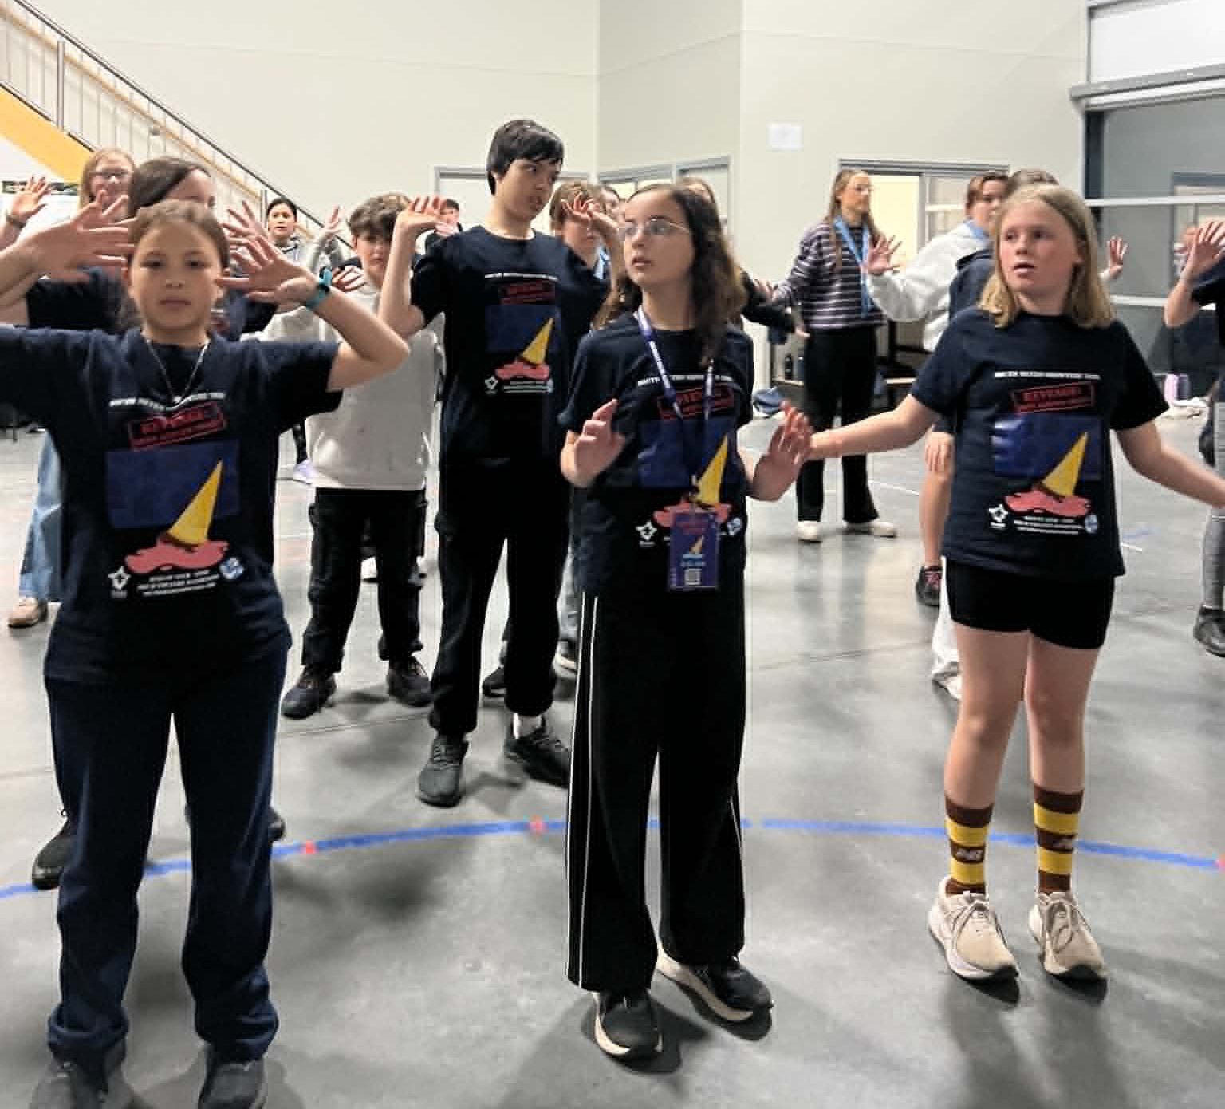
Today we had a busy afternoon rehearsal; after warmups, we went over ‘Sold! Sold! Sold!’ which we learnt last week, well done cast for remembering the moves!
Following this, we did a run through of all Act 1 items, including all of the sketches. Make sure to keep practicing your lines at home, but well done for listening out for which items were coming up next.
We then had a patrol challenge where each patrol had to present and act out little tasks to production and management team members in exchange for play money. Every patrol excitedly took to the challenge and competed to earn the most money.
After this, we split off to learn ‘Creatures of The Night’ and ‘Household Hallelujah’.
Great job today everyone! - Shea
Next Rehearsal
Special Rehearsal
🗓️ Date: Sunday 28th June 2026
🕔 Time: Special Rehearsal (Only certain cast will be required - Please see list for times on next page)
📍 Venue: 1st Carrum Downs (Rehearsal Venue)
💼 Please bring your Script, Pen, Water Bottle and Lanyard with name tag.
Whole Cast Rehearsal
🗓️ Date: Sunday 12th July 2026
🕔 Time: 5:45pm - 8:30pm
📍 Venue: 1st Carrum Downs (Rehearsal Venue)
💼 Please bring your Script, Pen, Water Bottle and Lanyard with name tag.
Duty Patrols: Sunday 12th July
Phoenix (Opening) - Palais (Closing)
Members in these patrols will need to arrive 10 mins earlier to set up and stay back to pack up (approx 10 mins).
Running late? Unwell? Can’t make it? Please text Stabby on 0432 285 154
28th June 2026 - Special Rehearsal
Special Rehearsal - Army Ant Dance (1:00pm - 3:00pm)
The following Cast members are required for a special rehearsal at 1:00pm:
Jackson L | Indie B | Nicole G | Kasey R | Noah B | Felicity W | Teagan P
Connor S | Bronwyn P | Jack B | Shea B | Georgia P | Ruby B | Abby W
Georgia R | Toby S | Amyra J | Tyler P

Special Rehearsal - Toybox Takedown (3:00pm - 5:00pm)
The following Cast members are required for a special rehearsal at 3:00pm:
Lara W | Aya B | Connor S | Laura A | Ruby B | Kasey R | Bronwyn P
Noah B
Special Rehearsal - The Detectives Directives (3:00pm - 5:00pm)
The following Cast members are required for a special rehearsal at 3:00pm:
Nicole G | Laura A | Jett B | Jackson L | Shea B | Olivia W | Cody B
Aya B

Special Rehearsal - Sketchy Business (5:00pm - 6:00pm)
The following Cast members are required for a special rehearsal at 5:00pm:
Breanne S | Noah B | Maxx M
If your name was not listed above, we’ll see you on 12th July.
South Metro Showtime BBQ Fundraiser

One of the ways we keep South Metro Showtime affordable for our families is through fundraising, and we're looking for volunteers to help at our upcoming Bunnings BBQ! Thank you to everyone who has signed up so far. Although we can use more help for our lunch and afternoon shifts.


📅 Sunday 28th June
📍 Bunnings Carrum Downs

By volunteering for a shift, you'll be helping:

🎭 Support the running costs of South Metro Showtime

💰 Keep cast fees as low as possible

🤝 Support the wider South Metro Showtime community

We are seeking volunteers for the following shifts:

☀️ Morning Shift – 8:00am to 11:30am (Full)

🍔 Lunch Shift – 11:30am to 2:00pm - (Required)

🌭 Afternoon Shift – 2:00pm to 4:30pm - (Required)

Parents, carers, family members, and supporters are all welcome to help. Even a few hours of your time makes a huge difference to the success of the fundraiser.

👉 To volunteer, please sign up using the Google Sheet via the link or QR Code provided.
https://docs.google.com/spreadsheets/d/1bqE18z70YcYbSlRskP9Qv2p8vBXaXEg5HGfXC3kSRX8/edit?usp=sharing

Thank you for helping South Metro Showtime continue to provide an amazing experience for our cast, crew, and families!

Countdown to Theatre: 63 Days
(as of 21st June 2026)

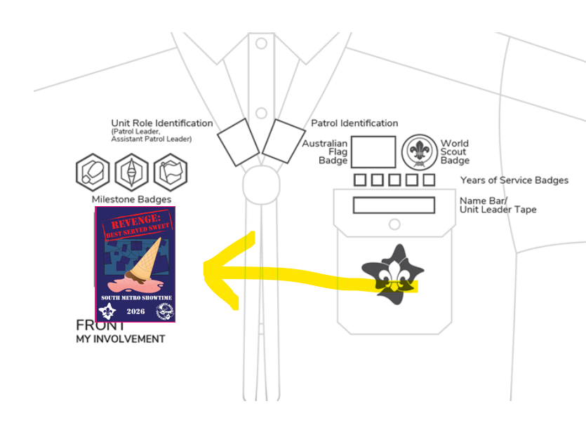
🎉 SMST Show Badges

🎭 The SMST Show Badge is a special event badge that celebrates your involvement in South Metro Showtime 2026:
REVENGE: BEST SERVED SWEET
The Showtime Show badges were handed out this week at rehearsals. If you were absent, please see Kate or
Stabby at the next rehearsal.

Scouts: The show badge is considered an event badge and should be worn under the Milestones section on the front of your uniform shirt.

Guides:
Guides 10-14 yrs wearing blue and orange polo and sash. Badge is sewn on the front of the sash right under the patrol emblem badge.

Guides 14-17 wearing either navy and orange polo or formal blue shirt. Badge is sewn directly onto the shirt on the right side 5cm below the collar. No sash to be worn with 14+ uniform shirts.

Please speak to the Guide Liaison Cat if you have any questions
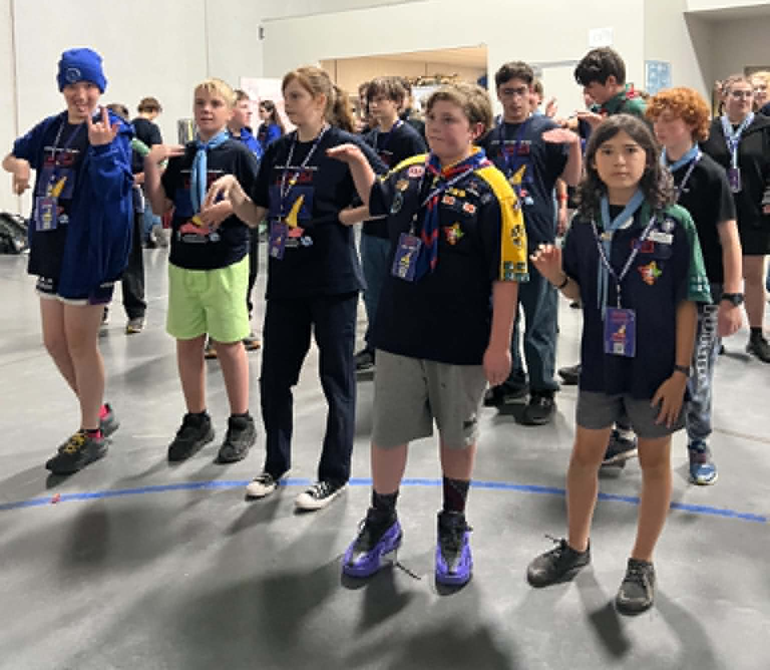
🍰 What Dessert Am I? - Quiz Question 🤔

I'm named after a fruit,

But I don't actually contain that fruit,

I'm creamy, sweet, and often yellow inside...

What am I? 🍰


Birthday Shoutouts!
A huge shout out and Happy Birthday to the following SMST Members who are celebrating their birthday this week (and during the holidays):
Amber Le (Princess)
Rosemary Miller (Palais)
Wishing all our SMST members a birthday filled with laughter, fun and lots of cake!

🧥 SMST Merch Store! Now Open
Want to rep Showtime in style and stay warm this winter? Our royal blue SMST zip-up hoodies are now available to pre-order through our online webstore! And now we’ve got Beanies too!
These are an optional extra and perfect for rehearsals, school, or just showing your Showtime pride out and about.
For Hoodies, once we receive 20 orders, the batch will be processed — so encourage your castmates to get on board too! Beanies are in stock right now!
🛒 Order now at:
https://shop.fullypromoted.com.au/south-metro-showtime
Please note the following,
- The first time you use the link, DON’T TRY TO CREATE A USER OR LOGIN
- Place the order for the items.
- When you go to check out fill out all the details
- At the end it will ask you to enter the password
- This will automatically create you a login
You can use this login to check what you have ordered in the past and make further orders after your first order 💙 Look sharp, stay cosy, and show off that Showtime spirit!

Centre Stage Advice from the PLs 🎭
A message from our Patrol Leaders sharing tips, reflections, and inspiration from their Showtime journey.

🌟 A Message from All Your Patrol Leaders 🌟

The school holidays are here, which means it's the perfect opportunity to keep building your Showtime skills!

While we're taking a break from rehearsals, the show doesn't stop. Every song you listen to, every dance you practise, and every set of lyrics you revise will help you feel more confident and prepared when we return.

We encourage everyone to go a little bit crazy with their practice over the holidays. Put the songs on in the car, sing along at home, run through your dances in the backyard, or grab a fellow cast member and practise together.

Remember, the more work you put in now, the easier it will be to learn new items and polish the show later in the season. When we come back from the holidays, let's impress the Creative Team by showing just how much progress we've made! Most importantly, have fun with it. Showtime is all about enjoying the journey, and practising now will help make the performances even more exciting later in the year.

Have a fantastic holiday break, and we'll see you back at rehearsal ready to shine! 🌟🎭🎶

— Your Patrol Leaders 💙
Social Media!
Adults (being over 18) in Scouting must not befriend Youth Members on social media, nor respond to requests to befriend (except family). This also applies in reverse, youth members (under 18) are not to follow or request to follow adults on Social Media.
Adults in Scouting should not interact privately with Youth Members in any form of social media. Where social media is used to organise events (Scouting activity) a publicly ‘open group’ or event/activity network involving more than one Adult and more than one Youth Member is to be used.
This provision does not mean that an Adult cannot also be a friend of a Youth Member, nor does it mean that an Adult cannot provide mentoring and support to individual Youth Members in their Scouting roles, however, in Child Protection terms, Adults in Scouting carry a higher duty of care, not only for Youth Members, but also to the Scout Association. This responsibility overrides the need for private relationships online.
Please email Breanne at marketing@southmetroshowtime.org if you need any clarification.

👕 Costume Requirements – Cast Supplied Items 👖
As we continue preparing costumes for the show, there are a few items that cast members will need to supply themselves.

🛒 Flavour Fever – Those casted as “Shop Goers”
- Bright coloured T-shirt (no logos)
- Blue jeans

📰 News Flash – Those casted as “General Public”
- Bright coloured T-shirt (no logos)
- Blue jeans
💡 If you are performing in both Flavour Fever and News Flash, you may wear the same T-shirt and jeans for both items.

🏠 Sold, Sold, Sold – Those casted as “Buyers”
- Button-up shirt or blouse
- Tidy/neat pants or a knee-length skirt
Please start looking for these items now so that costumes can check they are suitable well before show time.
If you have any difficulty sourcing any of the required items, please speak with the Costumes Team. We're happy to help and work with you to find a solution.
Thank you for helping bring our characters to life on stage! 🎭

Need support during rehearsals?
Our awesome Support Team is always around if you need anything. You can also get in touch with our
Support Manager Shelley Brown, at support@southmetroshowtime.org.

🎁 Help Us Source Trivia Night Prizes! 🎁

As we prepare for our upcoming South Metro Showtime Trivia Night, we are seeking donations to help make the event a huge success.
We are looking for:
- 🎟️ Vouchers
- 🎁 Prizes
- 🧺 Gift baskets
- 🖼️ Silent auction items
- 💼 Any other items businesses may be willing to donate
If you know of any local businesses, employers, family friends, or organisations who may be able to support South Metro Showtime, we would love your help in reaching out to them.
A donation request letter is available via the link below or using the provided QR Code.
Please feel free to pass this on when making contact with any potential donors.
If you do send a donation letter or approach a business, please also email Stabby so we can keep track of all contacts and avoid duplication. Email admin@southmetroshowtime.org
Link for donation letter: https://drive.google.com/file/d/1E5jSVCvEzV9Run_B0N80zzngboVdL37k/view?usp=sharing
Every donation, big or small, helps make Trivia Night a fantastic evening and directly supports South Metro Showtime in continuing to deliver an amazing experience for our cast, crew, and families.

Thank you for being part of the Showtime community! 🌟

