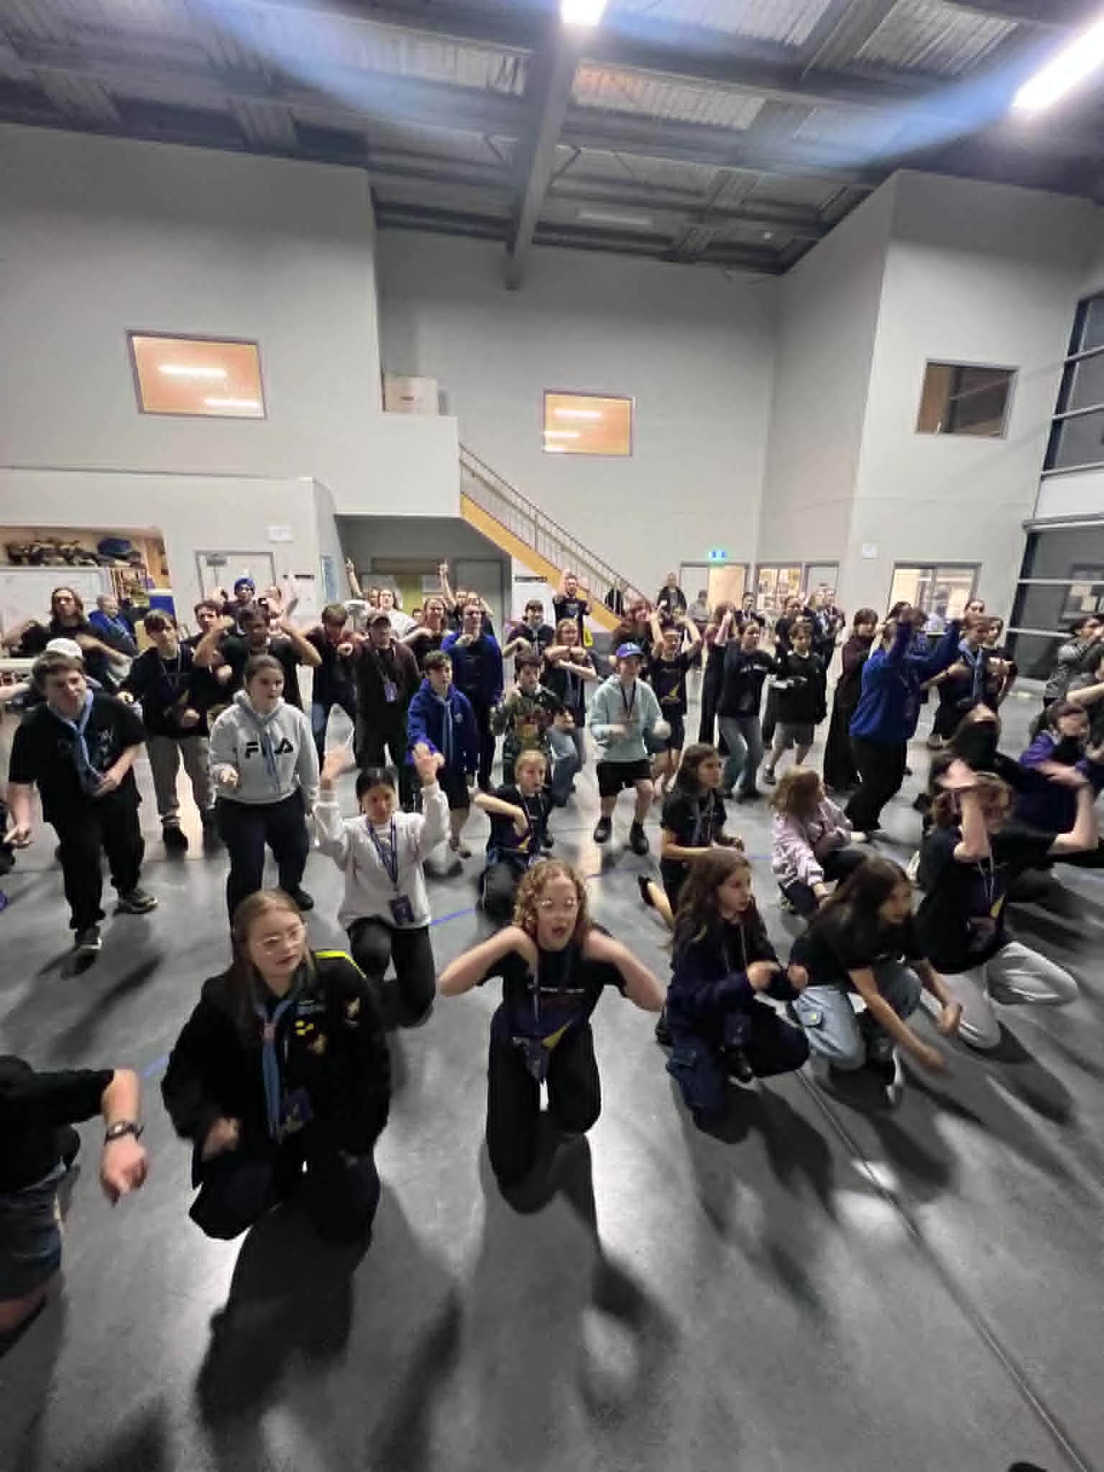
🎭 Rehearsal Recap
Another evening rehearsal completely smashed! We had an early rehearsal for Army ant march almost finished which is super exciting.
During warm ups instead of the usual dance warm up we went over some common moves we do throughout the show such as grapevine, cat in the hat, box step, just to name a few. Please keep practicing them at home! A good idea would be to put on one of your favourite songs and put the moves together.
We started act 2 with Sold! Sold! Sold! Finishing it and already looking stunning. Sold! Sold! Sold! It is super fast but the whole cast caught up extremely quickly, as it’s a very catchy and upbeat song. After Sold! Sold! Sold! We ran through all of Act one (excluding sketches), so exciting to have all of Act one done and dusted!
Great Job today cast!
-Lara
Next Rehearsal
🗓️ Date: Sunday 21st June
🕔 Time: 1:00pm to 6:00pm
📍 Venue: 1st Carrum Downs (Rehearsal Venue)
💼 Please bring your Script, Pen, Water Bottle and Lanyard with name tag.
Running late? Unwell? Can’t make it? Please text Stabby on 0432 285 154
Duty Patrols:
Regent (Opening) - Her Maj (Closing)
Members in these patrols will need to arrive 10 mins earlier to set up and stay back to pack up (approx 10 mins).
South Metro Showtime BBQ Fundraiser

One of the ways we keep South Metro Showtime affordable for our families is through fundraising, and we're looking for volunteers to help at our upcoming Bunnings BBQ! Thank you to everyone who has signed up so far. Although we can use more help for our lunch and afternoon shifts.


📅 Sunday 28th June
📍 Bunnings Carrum Downs

By volunteering for a shift, you'll be helping:

🎭 Support the running costs of South Metro Showtime

💰 Keep cast fees as low as possible

🤝 Support the wider South Metro Showtime community

We are seeking volunteers for the following shifts:

☀️ Morning Shift – 8:00am to 11:30am (5 volunteers required)

🍔 Lunch Shift – 11:30am to 2:00pm (6 volunteers required)

🌭 Afternoon Shift – 2:00pm to 4:30pm (5 volunteers required)

Parents, carers, family members, and supporters are all welcome to help. Even a few hours of your time makes a huge difference to the success of the fundraiser.

👉 To volunteer, please sign up using the Google Sheet via the link or QR Code provided.
https://docs.google.com/spreadsheets/d/1bqE18z70YcYbSlRskP9Qv2p8vBXaXEg5HGfXC3kSRX8/edit?usp=sharing

Thank you for helping South Metro Showtime continue to provide an amazing experience for our cast, crew, and families!

Countdown to Theatre: 70 Days
(as of 14th June 2026)

🎉 SMST Show Badges (Coming next week)

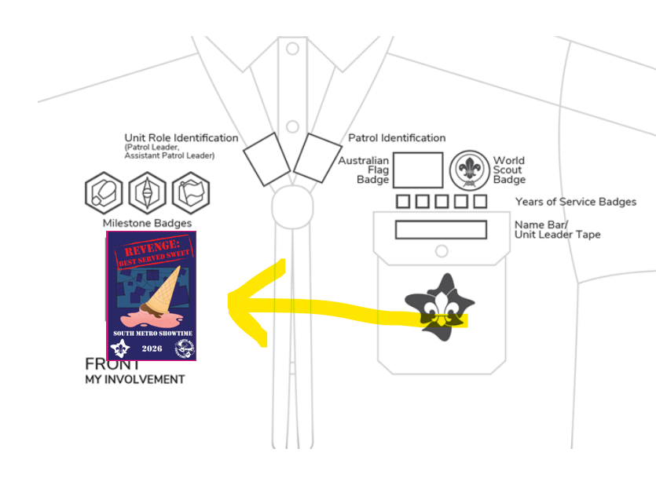
Next week our SMST Show badge will be handed out to all our amazing cast members.

🎭 The SMST Show Badge is a special event badge that celebrates your involvement in South Metro Showtime 2026:
REVENGE: BEST SERVED SWEET

Scouts: The show badge is considered an event badge and should be worn under the Milestones section on the front of your uniform shirt.

Guides:
Guides 10-14 yrs wearing blue and orange polo and sash. Badge is sewn on the front of the sash right under the patrol emblem badge.

Guides 14-17 wearing either navy and orange polo or formal blue shirt. Badge is sewn directly onto the shirt on the right side 5cm below the collar. No sash to be worn with 14+ uniform shirts.

Please speak to the Guide Liaison Cat if you have any questions
Social Media!
Adults (being over 18) in Scouting must not befriend Youth Members on social media, nor respond to requests to befriend (except family). This also applies in reverse, youth members (under 18) are not to follow or request to follow adults on Social Media.
Adults in Scouting should not interact privately with Youth Members in any form of social media. Where social media is used to organise events (Scouting activity) a publicly ‘open group’ or event/activity network involving more than one Adult and more than one Youth Member is to be used.
This provision does not mean that an Adult cannot also be a friend of a Youth Member, nor does it mean that an Adult cannot provide mentoring and support to individual Youth Members in their Scouting roles, however, in Child Protection terms, Adults in Scouting carry a higher duty of care, not only for Youth Members, but also to the Scout Association. This responsibility overrides the need for private relationships online.
Please email Breanne at marketing@southmetroshowtime.org if you need any clarification.

🤝 Parents & Supporters Team Meeting 🤝
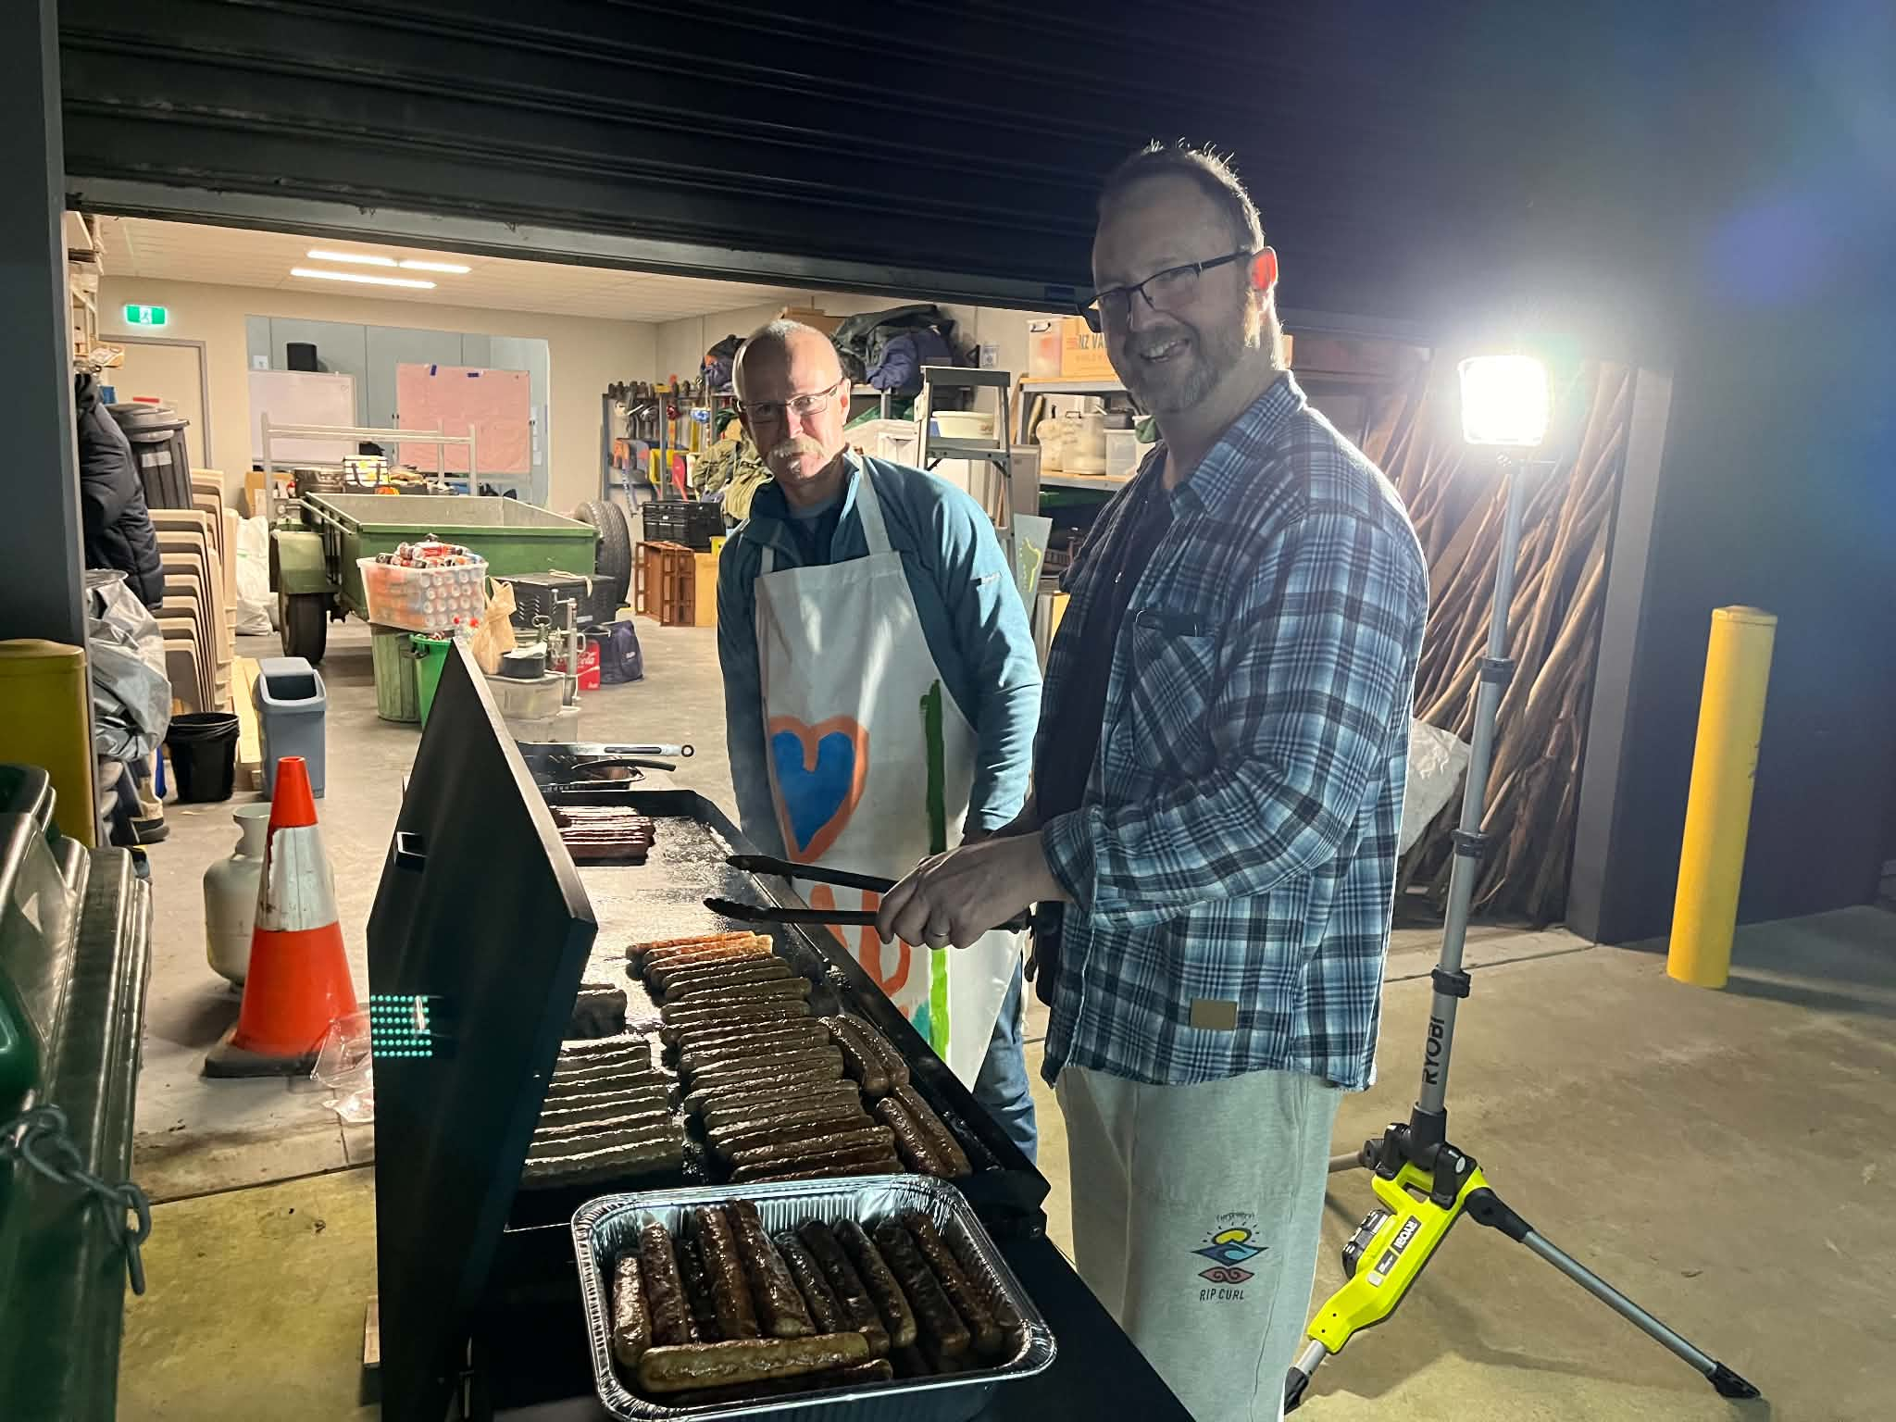
Our first Parents & Supporters Team Meeting for 2026 will be held on Sunday 21st June at 1:15pm!
This meeting will focus on planning and organising our upcoming Trivia Night Fundraiser, one of the key events that helps support South Metro Showtime and keep participation costs affordable for our families.
We'll meet briefly at the rehearsal hall before heading across to the local café for a coffee and a chat while we discuss ideas and plans for the event. ☕🎉
This meeting is open to:
- Parents and supporters who have already expressed their interest to Stabby
- Anyone who would like to become involved and help support Showtime throughout the season
Not able to make the meeting but still keen to help? No problem! Please let Stabby know, and we'll make sure there are still plenty of opportunities for you to get involved.

🍰 What Dessert Am I? - Quiz Question 🤔

I wobble when you shake me,

I come in many colours,

And if you throw me at a wall, I might stick there...

What am I? 🍰

🧥 SMST Merch Store! Now Open
Want to rep Showtime in style and stay warm this winter? Our royal blue SMST zip-up hoodies are now available to pre-order through our online webstore! And now we’ve got Beanies too!
These are an optional extra and perfect for rehearsals, school, or just showing your Showtime pride out and about.
For Hoodies, once we receive 20 orders, the batch will be processed — so encourage your castmates to get on board too! Beanies are in stock right now!
🛒 Order now at:
https://shop.fullypromoted.com.au/south-metro-showtime
Please note the following,
- The first time you use the link, DON’T TRY TO CREATE A USER OR LOGIN
- Place the order for the items.
- When you go to check out fill out all the details
- At the end it will ask you to enter the password
- This will automatically create you a login
You can use this login to check what you have ordered in the past and make further orders after your first order 💙 Look sharp, stay cosy, and show off that Showtime spirit!

Need support during rehearsals?
Our awesome Support Team is always around if you need anything. You can also get in touch with our
Support Manager Shelley Brown, at support@southmetroshowtime.org.

Centre Stage Advice from the PLs 🎭
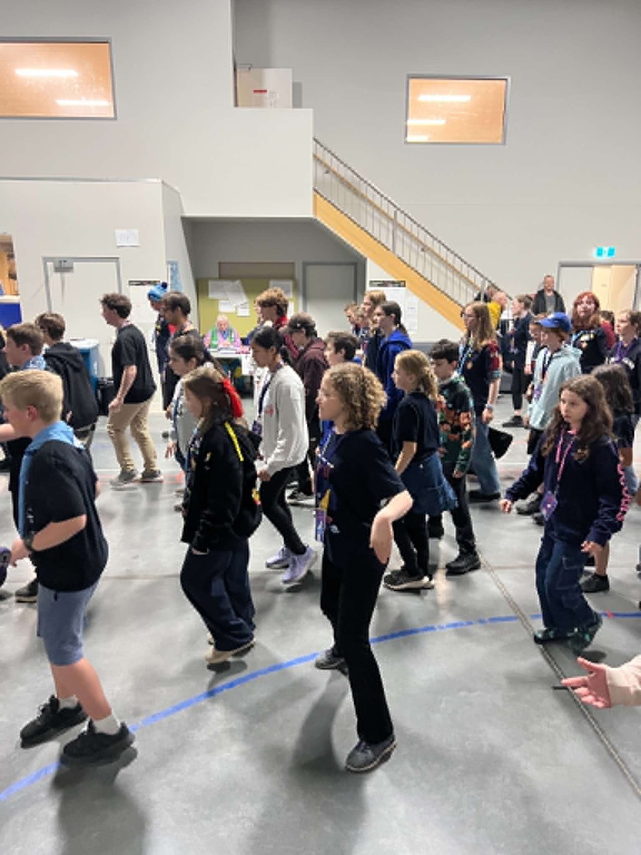
A message from our Patrol Leaders sharing tips, reflections, and inspiration from their Showtime journey.

🌟 Ryder – Astor Patrol Leader 🌟
One of the best things you can do throughout the Showtime season is to stay on top of your songs and keep practising them regularly.
As we learn more items and move further through the show, rehearsal time becomes increasingly valuable. The more familiar you are with your songs, the easier it is to focus on choreography, stagecraft, and bringing energy to your performance.
Try to spend a little time each week listening to the music and singing along. Regular practice will help build your confidence and ensure you're ready when it's time to put all the pieces together.
🧠🎉 Save the Date – South Metro Showtime: Trivia Night! 🎉🧠
Get your thinking caps ready and start assembling your dream team!
Our annual South Metro Showtime Trivia Night is coming up on:
📅 Saturday 25th July
Join us for an evening of fun, laughs, friendly competition, and fundraising as we work together to support the 2026 season of South Metro Showtime.
Whether you're a trivia master, a random-facts expert, or just there for a great night out, we'd love to see you there!
👀 More details are coming next week, including:
- Venue
- Start and finish times
- Table bookings and reservations
For now, mark Saturday 25th July in your calendar and start gathering your teammates.

